Sympathetic characters in Hippolytus

Introduction:

Although Aphrodite causes the tragedy, all three main characters contribute to their own downfall by their actions and choices and it is impossible to see any of them as wholly sympathetic.

Phaedra

Positive points

- Before she even appears in the play, we know she is in a bad way (pages 134-135)

- She hates the feelings she has for Hippolytus – she’s ashamed:

“madness came upon me, a god dulled my mind and I fell” (page 136)

- Is determined to keep silent

“Say something! Look at me!” (Nurse: page 138)

- Speech on pages 140-141

Has tried to keep silent
Self discipline
Will now die

“I wouldn’t want my sins witnessed by the world”
(Remember – she hasn’t done anything wrong)

Honours marriage

“And I despise them, women who preach faithfulness to husbands but dare the worst behind their backs” (page 141)

- Is determined not to bring disgrace to her husband

- Allows herself to be persuaded to use a (non-existent?) charm

“This charm – is it an ointment or a potion?” (page 144)

- Fears that Hippolytus will find out (page 144)

- Overhears what Hippolytus says about her

“Whore’s maid” “Betrayer of her master’s bed” (page 145)
(none of this is true)

- Has to endure listening to Hippolytus’ vicious speech (pages 146-7)

- By the actions of the Nurse, she is almost forced to commit suicide

“I have found a way out of this trouble of mine” (page 149)

Negative points

A bit hysterical?

“Ah if only..under poplars in some lush meadow..” (page 136)

- Eventually tells the Nurse (pages 139-140) but extreme emotional
pressure from her to do so.

- Plans to implicate Hippolytus to get back at him

“But in dying, I will prove deadly to another’s life, to teach him
not to triumph over my downfall” (page 149)

- Writes a note accusing Hippolytus of rape (page 152)

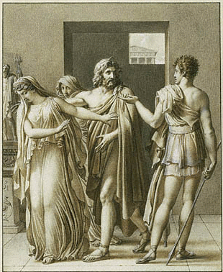

Hippolytus

Positive points

Devotion to Artemis

“Permit a devoted hand to set this garland on your golden hair” (page 133)

- Wants to comfort Theseus when Phaedra has been found dead

“That’s no help in a crisis, saying nothing…I am not just a friend” (page 155)

- Refuses to break his oath to save himself

“Why do I not unseal my lips…no, I will not” (pages 156-7)

- Accused of rape – the very last thing he would do!

“Ah, that hits me hard…to be thought as foul as this” (page 157)

- Will never see his friends again

“Come my young friends,..give me your goodbyes” (page 158)

- Accepts his fate

“Enough of these foolish tears: my father’s orders must be
obeyed….I no longer belong to this city” (page 159)

- Suffers terrible injuries (pages 160-1)

- Expresses his pity for Theseus

“O my poor father, I pity you for what has passed this day” (page 165)

- Forgives his father

“I absolve you of this bloodshed” (page 166)

Negative points

- Boastful? Proud?

“For I am the only mortal who has this privilege” (page 133)

- A bit of a prig

“No goddess worshipped by night wins my respect” (page 133)
(this could also be hubris)

Disrespectful of Aphrodite

“As for your Cyprian, she’s not mine…..good riddance!” (page 134)
(even the servant realises that this is a rash statement)

Very bad opinion of women which he expresses in a vindictive way

“dangerous pest”
“Why did you allow women to live …and plague mankind?” (page 146)

“Never will I have my fill of hating women” (page 147)

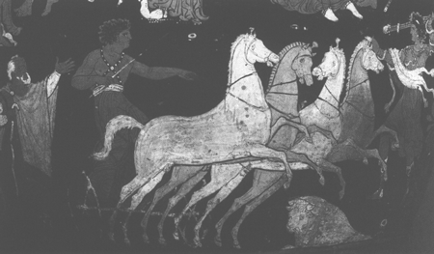

Hippolytus rides to his death

(Apulian krater, red-figure, c350-325 BC.)

Theseus

Positive points

Distress at learning of his wife’s death

“the one whose death is death to me..” (page 151)
“the greatest sorrow I’ve ever known” etc.

- Wants to die once he knows the truth about Hippolytus

“Mistress, I pray for death” (page 163)
“I am ruined, my son: all delight in life has gone” (page 165)
”Oh my son, I cannot bear it” (page 166)

- Regrets his hasty words – knows he was wrong to speak so hastily

“How I wish the words had never passed my lips” (page 165)

Negative points

Overly concerned with his own reputation?

“The letter – it cries out horrors! I am ruined, my life is over” (page 152)

- Very hot-headed – accepts the letter at face value and is quick to condemn Hippolytus.

“Hippolytus has dared to violate my wife” (Page 153)

- Curses Hippolytus with no thought and decides to exile him to make sure he suffers.

“I’ll banish him from Trozen, so one of two fates shall lay him low” (page 153)

- Jumps to conclusions

“Look at this man – my own son, he has shamed my bed” (page 154)

- Mocks Hippolytus’ way of life and beliefs – nasty.

“Oh yes, preen yourself, play the exhibitionist with that
vegetable diet of yours..” (page 154)
- Is determined to punish Hippolytus so that people do not regard him as weak.

“For if…..I allow you the victory…….the rocks will say I deal gently
with criminals” (page 154)

- Sarcastic when Hippolytus puts forward his defence

“Isn’t he a born magician…treating his father with contempt?” (page 156)

Vindictive – wants Hippolytus to suffer

“a speedy death is all too easy..” (page 156)

- Is pleased to hear that Hippolytus has been seriously injured

“Since I feel hate for the man…I took pleasure in this report” (page 161)

- Blames the gods for his actions?

“Yes, the gods had thrown me off balance: my thinking was
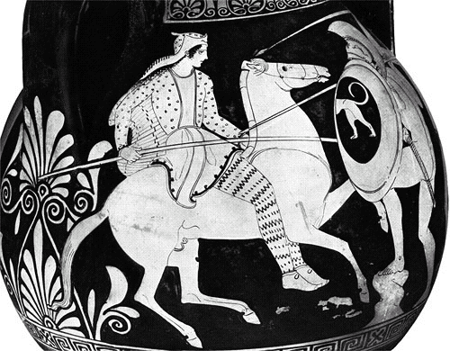
distorted” (page 165)

Concluding paragraph

Summarise in a few sentences what you have said in answer to the question, referring to the essay title. Your conclusion will possibly be that Phaedra is the most sympathetic character in the play, although she damages her reputation, and our opinion of her, by falsely accusing Hippolytus in order to make him suffer.

