The gods in Aeneid Book I

Read each section of the book outlined below and answer the questions in full sentences. Please set out your work in the same way and leave a line between each section. On a separate piece of paper, make a note of anything which has been inspired by Homer.

Page(s) God(s)

3-5 Juno a) Why does Juno hate the Trojans? (three reasons)
b) Find out about Athene burning the Greek fleet.
c) What does Juno ask Aeolus to do?
________________________________________________________________
6-7 (Aeolus) a) How does Virgil show the strength of the storm?
b) How does Aeneas react to the storm?
c) Where does the storm drive the Trojans?
________________________________________________________________
7-9 Neptune a) What relation is Neptune to Juno?
b) Why is he angry?
c) What does Neptune do and how does Virgil
emphasise the effect of this action?
________________________________________________________________

11-14 Jupiter/Venus (See separate sheet)
________________________________________________________________

14 Mercury a) Who sends Mercury down to the earth?
b) To what country does he go and why?
c) What is the name of the ruler of this country?
________________________________________________________________
14-18 Venus a) Why does Aeneas not recognise Venus, his mother?
b) What information does she give about the queen?
c) Briefly outline what Aeneas has been through (p17)
d) What does the omen of the eagle and swans mean?
________________________________________________________________
18 Venus cont’d a) How does Aeneas finally recognise the goddess?
b) What is his reaction to this?
c) What further help does Venus give to them?
________________________________________________________________
24 Venus a) How does Venus enhance Aeneas’ appearance?
________________________________________________________________
27-28 Venus (Cupid ) a) What does Venus intend to do to Ascanius?
b) What goddess does she want to get back at?
c) Explain what Cupid has to do at the banquet.
________________________________________________________________
28 Venus a) What happens to Ascanius and where is he taken?
________________________________________________________________
29 Cupid a) How does Cupid get close to Dido?
b) What effect does he gradually have on her?
________________________________________________________________

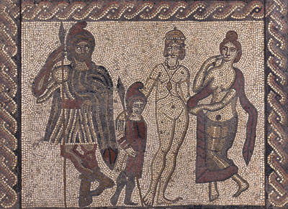

a b c d

This mosaic is from a Roman villa in Somerset and tells the story of Dido and Aeneas. Can you identify the four characters shown here?

