Name: ________________________ Class: １—____— _____
Lesson 5
Stage 1
On the telephone

Hello. This is <私の名前>.
May I speak to <友達の名前>?
My Character

Hello, <友達の名前>.
This is <私の名前>.
How are you?

Fine, thank you. Would you like to ___________ next Sunday?

選んでください
①play tennis ②go fishing
③go shopping ④go to karaoke

OK. I’ll be free _____________.
Great. I’ll come to your house at ________.
えらんでください①play tennis ②go fishing ③go shopping ④ go to karaoke
①in the afternoon ②in the morning ③in the afternoon ④ in the evening
えらんでください①play tennis ②go fishing ③go shopping ④ go to karaoke
えらんでください①play tennis ②go fishing ③go shopping ④ go to karaoke
①two ② five
③three ④six
えらんでください①play tennis ②go fishing ③go shopping ④ go to karaoke
①in the afternoon ② in the morning
③in the afternoon ④in the evening

OK. Thank you for calling. Goodbye.

Goodbye. See you on Sunday!
①in the afternoon ②in the morning ③in the afternoon ④ in the evening

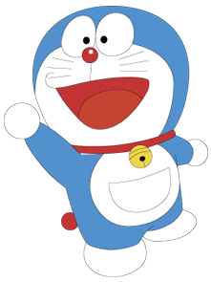  Doraemon | 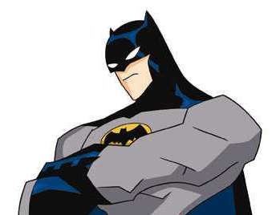  Batman | 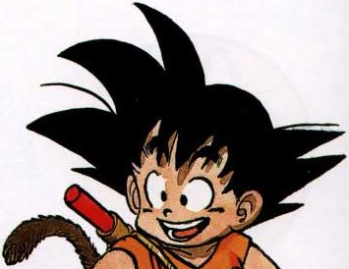  Goku | 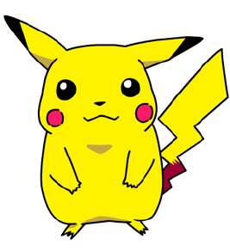  Pikachu | 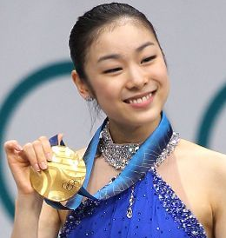  Kim Yu Na | 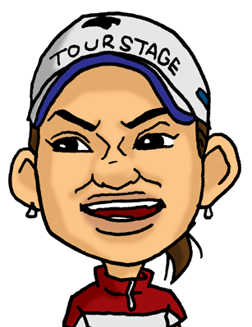  Ai Miyazato | 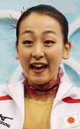  Mao Asada | Mr. Obama
  Snoopy | 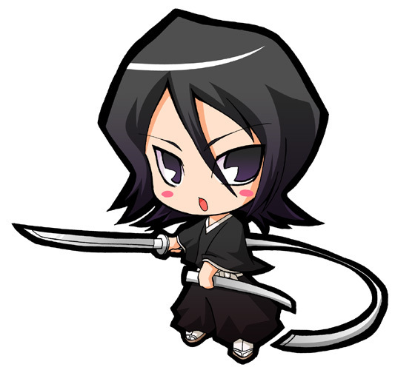  Rukia | 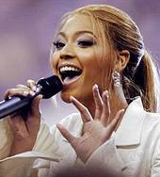  Beyonce | 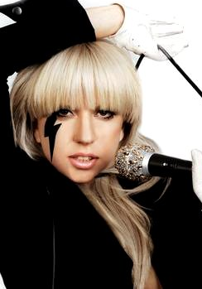  Lady Gaga | 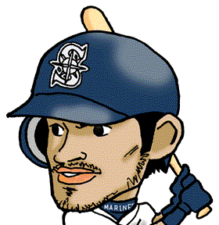  Ichiro Suzuki | Yoshio Kojima | 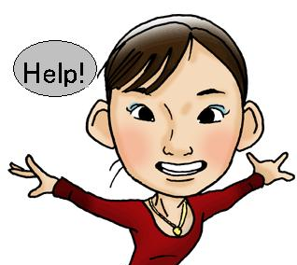  Miki Ando | 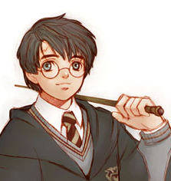  Harry Potter

I called
Character

Name

Character Cards
(Copy & paste to make many of them, print them off and cut them up)
Doraemon | Batman | Goku | Pikachu | Kim Yu Na | Ai Miyazato | Mao Asada | Mr. Obama
Snoopy | Rukia | Beyonce | Lady Gaga | Ichiro Suzuki | Yoshio Kojima | Miki Ando | Harry Potter

Doraemon | Batman | Goku | Pikachu | Kim Yu Na | Ai Miyazato | Mao Asada | Mr. Obama
Snoopy | Rukia | Beyonce | Lady Gaga | Ichiro Suzuki | Yoshio Kojima | Miki Ando | Harry Potter

Doraemon | Batman | Goku | Pikachu | Kim Yu Na | Ai Miyazato | Mao Asada | Mr. Obama
Snoopy | Rukia | Beyonce | Lady Gaga | Ichiro Suzuki | Yoshio Kojima | Miki Ando | Harry Potter

Doraemon | Batman | Goku | Pikachu | Kim Yu Na | Ai Miyazato | Mao Asada | Mr. Obama
Snoopy | Rukia | Beyonce | Lady Gaga | Ichiro Suzuki | Yoshio Kojima | Miki Ando | Harry Potter

