

Name of Worshipped Being: Kariya, Goddess of Disease – Chaotic Evil

Symbol: Black rat

Ancient Ruins: A spider crawling across a web

Goal and Purpose of Faith: The Goddess of Disease exists only to spread illness and ignorance. She creates new and ever-more-terrifying illnesses to inflict upon the sentient races. She and her clergy despise cleanliness.

Requirements of the Priest Hood: The priests want to and are required to spread illness and disease. They must carry infected victims and rats infested with disease-bearing insects to new ports.

Alignment Choices: Any evil alignment

Minimum Ability Scores: Wisdom 9, Constitution 15

Races Allowed: All races.

Gender: All genders

Bonus Non-weapon & Weapon Proficiencies: Pest Control, Specialization - Long bow

Non-weapon & Weapon Proficiencies required: Herbalism, Religion, Sage Knowledge: Toxicology

Non-weapon & Weapon Proficiencies recommended: Ancient History. Reading/Writing

Duties: Their goals, through their actions, are to deny their victims an honorable death and to topple civilizations. They see their main mission in life as bringing illness to communities that are too healthy and joyous.

Priest Hood Weapon Restrictions: Bows (all), dart, scourge, scythe, sickle, whip. No silver weapons.

Special Limitations: Priests of the Goddess of Disease must remain celibate (unmarried) and have as much sex as they possibly can with as many different people as possible in order to spread venereal diseases. Each cleric will roll on the chart below to determine which venereal disease they currently have (it will not cause the character pain or be observable to other characters):

1 - 20 % | Syphilis
21 – 40% | Gonorrhea
41 – 60% | Crabs
61 – 80% | Herpes
81 – 100% | Venereal leprosy

Spheres of Influences:
Major – All, Animal, Healing (reversed forms of spells only), Summoning, Weather
Minor – Combat, Divination, Necromantic (reversed forms of spells only), Protection (reversed forms of spells only, where applicable).
Granted Powers: Immunity to all diseases. Laying On of Hands (same as the Paladin ability, but reversed – it does damage, rather than curing damage). For the truly devout clerics of Kariya, she will make them Wererats.

Followers: First followers are received at 9th level and they consist of: one 5th level priest, three 3rd level priests and six first level priests of the same order, plus ten 1st level fighters.

Relations: Other Faiths, Aristocracy, People: The Goddess Kariya does not like the gods of Healing, and Strength or their non-Evil aligned children (Minor-Gods) or their Chosen and the Minor-Gods of Fertility and Knowledge. The priests tend to follow their Goddess’ otherworldly alignments with various gods. Kariya and her clergy are on good terms with the gods of Death, and War. Kariya and Feayeur’s children’s grandmother is Brundin, Goddess of War. Brundin adores all her grandchildren by Kariya and Feayeur. Their grandfather is Pryden, God of Strength. Pryden does not favor any of his grandchildren by Kariya, because he despises her and anything to do with her as weakness.

Strongholds of the priesthood are usually secret. They must either be built in the wilderness, or may be built in a community if it is disguised as some other facility.
Requirements of the Followers: None.
Alignment Choice(s): Normally evil.
Races Allowed: Any.
Restrictions: No restrictions.

Human Avatar Form Information:

Appearance & ‘Natural’ Abilities: Kariya appears as Human female with black hair and ice blue eyes (see picture at left). Ability scores: 25 all. Natural Armor Class: -25. THAC0: -21. Evasion 99%. Hit Points: 510. Regeneration 1d10+7 per round.

Armor: Bodies Bane is made of bones of many creatures, bound together by ligaments and decaying flesh to allow movement. It is magical +5 armor. The armor radiates a 10’ globe of disease, fear, and protection from good. If a priest wears the armor, it raises the individual’s effective experience level by 2, but only to turn or befriend undead. This is the only magical armor Kariya will allow her priests to wear, as a god-gift.

Weapon’s Powers in the Hands of Kariya: Disease Slinger is a magical long bow that gives a +5 to initiative and has triple the range of normal long bows. This black ebony wood bow has tiny enchanted carvings of rats with ruby eyes at each end. When the bowstring is drawn, the red eyes glow and create an arrow that must be fired within the next three rounds or vanish. The arrows are as follows (roll 1d6 to determine arrows):

Arrows:
- (roll 1 or 2) Disintegrate Flesh – the being struck with this arrow begins to disintegrate as if plagued with leprosy. Part of their anatomy begins to fall off if they to not make a saving throw vs. spell to avoid disintegration initiation right then. The saving throw stops arms and legs from falling off the body for the time being, but the person must still be healed by a Remove Curse spell within 1d10 days plus Constitution bonus or the leprosy begins to take effect. Skin turns a sickly green and sores appear oozing puss. Skin breaks and peels off causing 1d4 points of damage each day until death comes or the curse is removed. Creatures immune from all diseases (magical and otherwise) are unaffected.

- (roll 3 or 4) Evaporate Bodily Fluids – the being struck with this arrow has their bodily fluids set to fever (energy drain). Their blood and other bodily fluids begins to weep out their pores or any exposed skin or orifices, such as nostrils, mouths, ears, and eyes, causing pain and a cloudy mist made of their fluids to appear in a 5’ circle around them. Any other creatures that are touched by the diseased mist are also inflicted by this pestilence. All creatures inflicted must save vs. spell to ignore the effects. If they fail, they suffer an initial 10d6 points of damage. After initial damage, the inflicted creature(s) will continue to loose 1d6 hit points per round until healed by a Restoration spell. If they are not healed, they will continue to loose hit points. Every 25% of their total hit points lost before healing will cause a permanent loss of one Constitution point. Creatures immune from all diseases (magical and otherwise) are unaffected.

- (roll 5 or 6) Weakness – the being struck with this arrow is set upon by a temporary palsy of feebleness that reduces the creature to a Strength of 3. They begin to shake and convulse vomiting and defecating as if they are struck by a severe flu. For human or humanoid creatures, this results in an attack penalty of –3 and a damage penalty of –1 with handheld or thrown weapons. Monsters instead suffer an attack penalty of –3 and reduce each die of damage inflected by 1 point. Regardless of this penalty, any successful attack inflicts at least 1 point of damage. Note that characters in armor of almost any kind will certainly become moderately or heavily encumbered by the effects of this arrow, with additional movement, attack, and defense penalties as noted in Chapter 6 of the Player’s Handbook. The effect lasts for 1d20 + 5 rounds.

On an unmodified roll of 20 on an attack with Disease Slinger, the arrow enters the heart of the target, killing it instantly. This assumes the target has a heart – undead, non-corporeal creatures, and creatures with unusual anatomies, such as oozes, are not affected. Other abilities of Disease Slinger:

Acts as a ring of human influence on command | Cause ghoul-like paralysis 1/day
Cause fear 120’ radius 3/day | Spider climb 3/day
Cause disease 2/day

Weapon’s Powers in the Hands of Mortals: The bow performs for mortals as would for Kariya, but has the following penalties to its use:

- Those who are not worshipers of Kariya that attempt to use the bow are struck with a degenerative disease that drains 1 point of Constitution per week until the ability reaches 0 and they die. Once contracted, the disease runs its course even if ownership of the bow should change. Mere handling of the bow does not trigger this effect; the weapon must be used for some purpose – such as combat. This disease can be halted by cure disease, but the character cannot recover any Constitution until a remove curse spell is also cast. Constitution points are regained at 1 point per week. (** When Identify is cast upon the bow, it shows as a +5 bow of quickness)

- Disease Slinger is also imbued with a spirit of intense evil (Int 19, Ego 28). The spirit attempts artifact possession, and once this occurs, the character gradually becomes a triple-strength (12+3 HD) Were-rat of Chaotic Evil alignment. Once the transformation is completed, the character becomes a permanent NPC. Determining time for complete possession: Roll 1d20 and subtract the result from the Intelligence of the character being possessed to yield the duration of time for a complete possession in weeks. If the result is 0 or less, roll 1d12 instead to find the duration in days. The possession can be halted by a 14th Level Cleric Ceremony. The possession will not be complete, but effects of the process will not be reversed as rolled:

  - 00 – 25% = no ill effects are suffered
  - 26 – 50% = is cursed with lycanthropy – Were-rat (12+3 HD)
  - 51 – 75% = multiple personality (roll 3d12 to determine # and 1d6 to determine alignment of each personality)
  - 76 – 100% = alignment permanently changed to Chaotic Evil

- The spirit of the bow seeks nothing but to cause mayhem and disease upon the mortal races of the world. If not quenched in diseased humanoid blood at least once a month, the bow refuses to use its invoked powers.

Three Minor-Gods/Goddesses and One-God of the Major Pantheon spawned by the Goddess of Disease, sired by Frayeur, Minor-God of Terror:



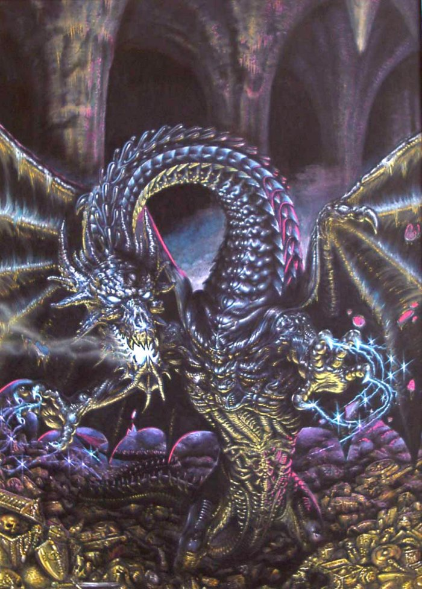
Name of Worshipped Being Admettre, Minor-Goddess of Ignorance – Chaotic Evil (killed by Paragon Argentus and Alex Didndoit) reborn as a Black Dragon half-ascended demi-goddess. Whereabouts unknown.

Symbol: A dragon breathing acid on a stack of books and maps

Goal and Purpose of Faith: To destroy the mortal knowledge base so sentients are more reliant on the wisdom of gods and easier to manipulate and control.

Requirements of the Priest Hood: Burn books; demolish libraries or other storehouses of knowledge and wisdom. Actively seek out Sages, Librarians, and other highly knowledgeable people capable of creating books and passing down wisdom and destroy them.

Alignment Choices: Chaotic Evil

Alignment Choices: Chaotic Neutral, Neutral Evil, or Chaotic Evil
Minimum Ability Scores: Strength 15, Charisma 16

Maximum Ability Scores: Wisdom 8, Intelligence 8

Races Allowed: Any

Gender: Any

Bonus Non-weapon & Weapon Proficiencies: none

Non-weapon & Weapon Proficiencies required: none

Non-weapon & Weapon Proficiencies recommended: Religion

Duties: To aid their God in reascending to the heavens by converting sentients to her worship and gaining her additional powers from daily prayer. To get frenzied crowds/mobs of worshippers to carry out the goals and purpose of the faith.

Priest Hood Weapon Restrictions: none

Spheres of Influences: currently the Goddess has no powers to bestow upon her Clerics; these spheres are granted by the Goddess Kariya in return for Admettre’s Clerics being ‘on call’ whenever she wants them.
Major – All, Animal, Healing (reversed forms of spells only), Summoning, Weather
Minor – Combat, Divination, Necromantic (reversed forms of spells only), Protection (reversed forms of spells only, where applicable).
Granted Powers: Mind blank; Inspire Fear

Followers: None granted – yet.

Relations: Other Faiths, Aristocracy, People: The Goddess Admettre does not like the gods of Healing, and Strength or their non-Evil aligned children (Minor-Gods) or their Chosen and the Minor-Gods of Fertility and Knowledge. The priests tend to follow their Goddess’ otherworldly alignments with various gods. Admettre and her clergy are on good terms with the gods of Death, and War. Admettre despises Paragon Argentus and Alex Didndoit and actively works with other gods and goddess who feel the same way to destroy the pair.

Requirements of the Followers: Must offer shelter and assistance to Clerics of the Goddess and all other deities’ clerics that serve a descendant of Kariya as needed; Must pray daily.
Alignment Choice(s): Any Neutral or Chaotic alignment not containing the element Good.
Races Allowed: Any.
Restrictions: No restrictions.

Armor: No armor of his own power – granted armor from her Mother.

Weapon Powers in the hands of Admettre: No weapons of her own power – granted weapons from her Mother

Weapon’s Powers in the hands of a mortal: Admettre never gives her weapons to mortals.



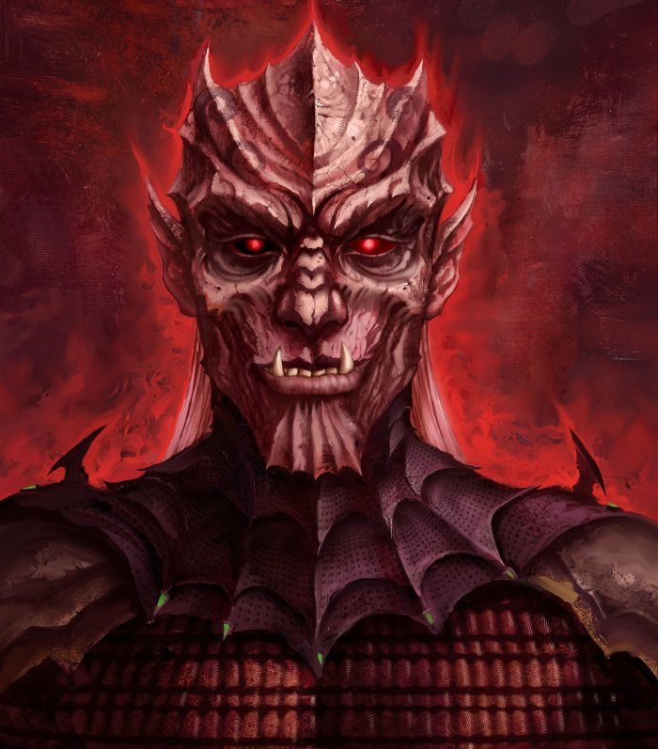
Name of Worshipped Being Vengeât, Minor-God of Justice/Revenge – Chaotic Neutral (split personality-insane) (killed by Paragon Argentus and Alex Didndoit) – Reborn as an Ogier-Mage enthroned on Slugmyre in Utca, half-ascended demi-god

Symbol: Silver Scorpion holding the scales of Justice in its claw

Goal and Purpose of Faith: To protect the rights of those deserving of justice (worshippers of the Evil gods) and met out revenge against those opposing justice – as Vengeât sees it.

Requirements of the Priest Hood: Whenever possible, act as judge over trials of those who have done wrong against those deserving justice. Promote Vengeât’s code of ethics. Enforce Vengeât’s code of ethics. Must try to infiltrate and subvert other judicial systems and attempt to change the infiltrated system into one that functions for the benefit of Vengeât’s worshippers; especially those that espouse Dalnoth’s ethos.

Alignment Choices: Chaotic Neutral, Lawful Neutral, or Lawful Evil

Minimum Ability Scores: Wisdom 15, Intelligence 17

Races Allowed: All races except humans. Ogiers highly favored.

Gender: Any

Bonus Non-weapon & Weapon Proficiencies: Sense Motive, Voice Mimicry

Non-weapon & Weapon Proficiencies required: Religion, Diplomacy, Law, and Persuasion

Non-weapon & Weapon Proficiencies recommended: Administration, Bureaucracy, Information Gathering, Intimidation, Investigation, Sage Knowledge: Law

Duties: To aid their God in reascending to the heavens by converting sentients to his worship and gaining him additional powers from daily prayer. To get frenzied crowds/mobs of worshippers to carry out the goals and purpose of the faith. **DM note: First PC to select Cleric of Vengeât will have a hand in writing the Ethics of Vengeât and gain chosen status should they complete the god’s quest. Those aiding in reestablishing Vengeât in the heavens will be granted weapons and armor befitting a god’s champion.

Priest Hood Weapon Restrictions: none

Spheres of Influences: currently the God has no powers to bestow upon his Clerics; these spheres are granted by the Goddess Kariya in return for Vengeât’s Clerics being ‘on call’ whenever she wants them.
Major – All, Animal, Healing (reversed forms of spells only), Summoning, Weather
Minor – Combat, Divination, Necromantic (reversed forms of spells only), Protection (reversed forms of spells only, where applicable).
Granted Powers: Mind blank; Inspire Fear

Followers: None - yet

Relations: Other Faiths, Aristocracy, People: Outcast from the heavens due to his defeat by Paragon Argentus and Alex Didndoit, Vengeât lives as an Ogier-Mage enthroned as Emperor on Slugmyre in Utca. The God Vengeât does not like the gods of Healing, and Strength or their non-Evil aligned children (Minor-Gods) or their Chosen and the Minor-Gods of Fertility and Knowledge. The priests tend to follow their Gods’ otherworldly alignments with various gods. Vengeât and his clergy are on good terms with the gods of Death, and War. Vengeât despises Paragon Argentus and Alex Didndoit and actively works with other gods and goddess who feel the same way to destroy the pair – seeking revenge for his ousting from the heavens.

Requirements of the Followers: Must offer shelter and offer assistance to Clerics of the God and all other deities’ clerics that serve a descendant of Kariya as needed. Must pray daily.
Alignment Choice(s): Chaotic or Lawful, Neutral or Evil
Races Allowed: Any
Restrictions: Must seek employment as soldiers, guards, city watch, enforcers, or bankers. Hangmen, assassins or executioners also highly encouraged.

Armor: No armor of his own power – granted armor from his Mother.

Weapon Powers in the hands of Vengeât: No weapons of his own power – granted weapons from his Mother

Weapon’s Powers in the hands of a mortal: Cannot grant his mother’s weapons to a mortal.



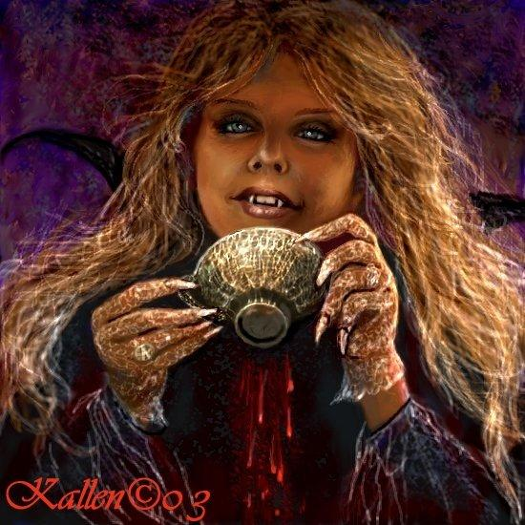
Name of Worshipped Being Tromperie, Minor-God/Goddess of Mischief & Trickery – Chaotic Evil (killed by Paragon Argentus and Alex Didndoit) – Reborn as a Male Cambian, wearer of all three pieces of the evil Regalia of Might. (killed a second time by Wella and Tholin Martel del Stoneheart) – Reborn as Female Half-ling Vampire – half-ascended demi-goddess.

Symbol: Hermaphrodite with wings and fangs

Goal and Purpose of Faith: To encourage underhanded deals, sabotage, forgery, counterfeiting, slander, liable, thievery, the breaking of laws and contracts, general lawlessness, lies, and situations where sentients are duped, tricked, or conned into serving the causes of gods, goddesses, governments or persons they are normally opposed to, to their ultimate detriment.

Requirements of the Priest Hood: Must dual class as a Thief or Bard (subclasses of Charlatan or Blade/Assassin/Spy) by 15th level.

Alignment Choices: Chaotic Neutral, Neutral Evil, or Chaotic Evil

Minimum Ability Scores: Wisdom 15, Charisma 17

Races Allowed: Any humanoid race. Half-lings highly favored.

Gender: Any or none – hermaphrodites highly favored. To determine gender for Clerics of Tromperie role as follows:

1% - 10% | Hermaphrodite
11% - 50% | Female
51% - 89% | Male
90% - 100% | Neuter – no gender

Hermaphrodites receive + 2 to their Charisma and Appearance, and can Charm as a Vampire. All characters must roll attraction to the hermaphrodite cleric. Rolls of 12 are automatically smitten and under extreme influence of the Cleric. Hermaphrodites hold a special place in the Goddesses heart for no other beings can understand being both male and female as the Goddesses herself has been. She grants a bonus to all Hermaphrodites on their god calls, wither they are Clerics or not, of a + 20. She almost never refuses their request.

Bonus Non-weapon & Weapon Proficiencies: Forgery, Hypnotism, Looting, Scribe, Voice Mimicry

Non-weapon & Weapon Proficiencies required: Artistic Ability, Disguise, Persuasion, Reading/Writing, Religion, Language: Hand-cant

Non-weapon & Weapon Proficiencies recommended: Information Gathering, Law, Local History, Ventriloquism

Duties: To aid their Goddess in reascending to the heavens by converting sentients to her worship and gaining her additional powers from daily prayer. Each Cleric must spread lies to at least two people a day if within a community. They must never use actual coin of the realm, but counterfeited coinage they make themselves. Intercepting communications and forging new documents with altered information to create confusion and chaos is highly encouraged. Acting as a trafficker in information (or misinformation) or as head of a Thief Guild is appropriate, as is being a member of a thief guild. Must only hold religious observances after the sun has gone down; requires a blood sacrifice once per month, preferably human.

Priest Hood Weapon Restrictions: no silver weapons; cannot create new vampires without the Goddesses consent.

Spheres of Influences: currently the Goddess has no powers to bestow upon her Clerics; these spheres are granted by the Goddess Kariya in return for Tromperie’s Clerics being ‘on call’ whenever she wants them.
Major – All, Animal, Healing (reversed forms of spells only), Summoning, Weather
Minor – Combat, Divination, Necromantic (reversed forms of spells only), Protection (reversed forms of spells only, where applicable).
Granted Powers: Will turn Clerics swearing undying faithfulness to her into Vampires. All abilities of a vampire – polymorph into bats, wolves, mist, shadow. Control lesser undead. Energy drain. Mind blank; Inspire Fear.

Followers: None granted – yet.

Relations: Other Faiths, Aristocracy, People: Outcast from the heavens due to his defeat by Paragon Argentus and Alex Didndoit, and then again by Wella and Tholin Martel del Stoneheart Tromperie is in hiding as the leader of a thieves guild in one of the major cities of the realms. The Goddess Tromperie does not like the gods of Healing, and Strength or their non-Evil aligned children (Minor-Gods) or their Chosen and the Minor-Gods of Fertility and Knowledge. The priests tend to follow their Goddess’ otherworldly alignments with various gods. Tromperie and her clergy are on good terms with the gods of Death, and War. Tromperie despises Paragon Argentus and Alex Didndoit and actively works with other gods and goddess who feel the same way to destroy the pair – seeking revenge for her ousting from the heavens. Tromperie has had some joy in learning of the death of Wella, but still wishes the death of Tholin Martel del Stoneheart and has a bounty on his head of 100,000 gold.

Requirements of the Followers: Must offer shelter and offer assistance to Clerics of the Goddess and all other deities’ clerics that serve a descendant of Kariya as needed. Must pray daily as the moon rises.
Alignment Choice(s): most often Chaotic and either Neutral or Evil
Races Allowed: Any
Restrictions: Cannot assist in upholding the laws of the land or in capturing thieves.

Armor: No armor of her own power – granted armor from her Mother.

Weapon Powers in the hands of Tromperie: No weapons of her own power – granted weapons from her Mother

Weapon’s Powers in the hands of a mortal: Cannot grant her mother’s weapons to a mortal.


Name of Worshipped Being: Mauvais, God of Evil – Lawful Evil

Symbol: Golden serpent wrapped around rams horns

Goal and Purpose of Faith: To spread maliciousness, anger, fear, aggression, and general evil while repressing good and good-naturalness as a whole.

Requirements of the Priest Hood: Never to commit a good act. To harm and mutilate all things promoting good. To spoil all goodness they come in contact with throughout their lives attempting to corrupt it to serve evil purposes.

Alignment Choices: Any Evil.

Minimum Ability Scores: Wisdom 17, Intelligence 18

Races Allowed: Any

Gender: Any

Bonus Non-weapon & Weapon Proficiencies: Hypnotism, Sage Knowledge: Toxicology, Sense Motive

Non-weapon & Weapon Proficiencies required: Dirty-fighting, Observation, Reading/Writing, Religion

Non-weapon & Weapon Proficiencies recommended: Anatomy, Disguise, Law, Looting, Mental Resistance

Duties: Be evil, act evil, and spread evil wherever and whenever they can.

Priest Hood Weapon Restrictions: No restrictions other than clerics must choose the most cruel and painful weapons to use. While in combat, they must attempt to prolong a victim’s pain and suffering in an attempt to cause the good person to turn to evil ways with a promise of clemency or healing.

Spheres of Influences:
Major – All, Combat, Necromantic, Divination
Minor – Summoning, Astral, Charm

Granted Powers: Constant Protection from Good 15’ radius in effect. Dual class as a Necromancer without penalties. For every good person turned to the worship of Evil, the cleric will receive a special granted power from the God.

Followers: First followers are received at 11th level and they consist of: one 8th level priest, three 6th level priests and six 4th level priests of the same order, plus special agents whose class is determined by a d4 roll. These agents consist of: 1 – a single 5th level character, 2 – a single 3rd level character, 3 - two 2nd level dual class characters, and 4 - 1st level characters, all normally Necromancers or Fighters. At 20th level gain an 11th level Oracle (Mage of Divination), and 1d20 bone golems.

Relations: Other Faiths, Aristocracy, People: The God Mauvais does not like the gods of Healing, and Strength or their non-Evil aligned children (Minor-Gods) or their Chosen and the Minor-Gods of Fertility and Knowledge. The priests tend to follow their Gods’ otherworldly alignments with various gods. Mauvais is on good terms with his former lover, Tisbe, and his daughters by her. Despite Tisbe’s good nature, Mauvais feels he has tainted her with his offspring, and thus can stand to be in her presence. Now that Tisbe is no longer the consort of Piacce, Mauvais finds himself drawn to her more often than not than to any other female. He attempts many plots that will draw her attention to him.

Requirements of the Followers: Must pray daily
Alignment Choice(s): Any Neutral or Evil
Races Allowed: Any
Restrictions: Cannot help goodly causes

Human Avatar Form Information:
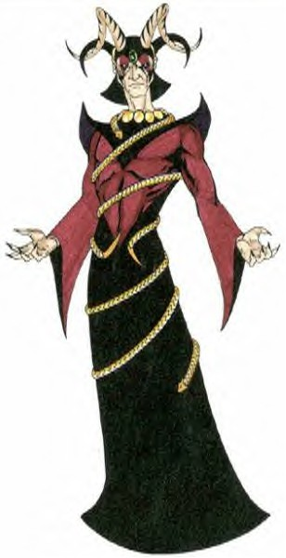

Appearance & ‘Natural’ Abilities: Mauvais appears as Human male with black hair and black/red eyes (see picture at left). Ability scores: 25 all. Natural Armor Class: -25. THAC0: -21. Evasion 99%. Hit Points: 510. Regeneration 1d10+7 per round.

Armor: See picture to left – The Robes of Mauvais convey the following powers: AC + 6, doubles speed, spell fire.

Weapon Powers in the hands of Mauvais: Chaotic in nature, Mauvais Scorching Blade has an intelligence that is squashed by the presence of the god, yielding all of its power’s without the consequences. This keen weapon is +5 when striking, is a dancing sword, and drains energy levels. On a roll of 11 – 20 it will drain all the energy levels from any being if it hits, causing instant death. With a roll of 7 – 10 it drains half of the energy levels. Mauvais can direct the energy levels at any living being within a 500’ radius of him using them as a laser beam causing the number of levels drained xd20 worth of wounding fire damage. Mauvais especially enjoys the irony of using one person’s life energy against another, especially traveling companions. He laughs malevolently which causes all enemies to make a morale check at -5.

Weapon’s Powers in the hands of a mortal: Chaotic in nature, this sword has an Intelligence of 22 and an Ego of 18, is +3 when striking, is a dancing sword, and drains energy levels. On a roll of 11 – 20 it will drain all the energy levels from any being if it hits, with a roll of 7 – 10 allowing it to drain on-half of the energy levels. The energy levels gained from the battle are transferred to the user as Strength of 18/00. It also adds hit points by automatically rolling the proper die for the creature struck. If a wizard is hit, roll 1d4 and multiply the result by the wizard’s levels. The same is done for all other classes and creatures. The sword becomes sated after draining off 300 energy levels, in which case, after 10 melee rounds, the user reverts back to his or her former Strength and hit points. The sated state lasts for 50 full turns, at the end of which the sword will take another 300 levels. If the mortal using the sword cannot dominate it’s Chaotic Evil nature, the sword will attempt artifact possession and cause the user to go on quests of the sword’s choosing.

Three Minor-Goddesses spawned by the Goddess of Love, sired by Mauvais, God of Evil:


Name of Worshipped Being: Convotise – Minor-Goddess of Infatuation & Lust

Symbol: Six sided purple star on a yellow background

Family relations: Least favorite daughter of Mauvais for the simple reason that she reminds him too much of Tisbe. This has caused problems as he finds himself unnaturally attracted to Convotise. For this reason, he has banned her from his presence for the foreseeable future. Convotise works to further none of her father’s goals, preferring to please only herself.

Goal and Purpose of Faith: To seduce the loyal, faithful, and chaste from their sworn duty and beliefs via guile and sexual acts for the purpose of weakening the gods whom the seduced worship.

Requirements of the Priest Hood: Actively seek to convert the loyal, faithful and chaste of the goodly gods into the worship of Convotise.

Alignment Choices: Any Evil

Minimum Ability Scores: Wisdom 12, Charisma 19, Appearance 20

Races Allowed: Any

Gender: Any

Non-weapon & Weapon Proficiencies required:
Non-weapon & Weapon Proficiencies recommended:

Duties:

Priest Hood Weapon Restrictions:

Special Requests/Limitations:

Spheres of Influences:
Major – All, Charm, Creation, Divination, Protection
Minor – Animal, Guardian, Healing, Necromantic

Granted Powers:

Followers:

Relations: Other Faiths, Aristocracy, People:

Requirements of the Followers:
Alignment Choice(s):
Races Allowed: Any.
Restrictions:


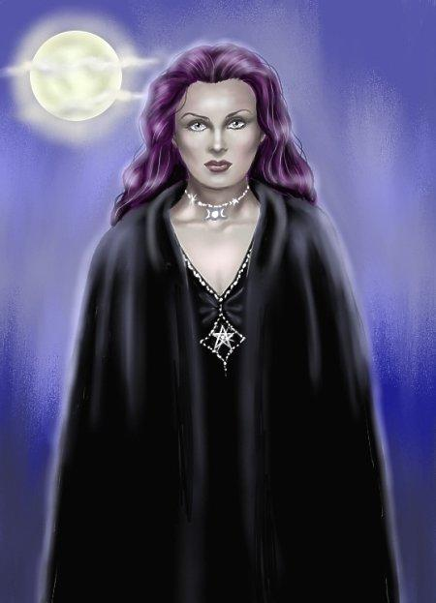
Name of Worshipped Being: Rancune, Minor-Goddess of Hate & Malice

Symbol: Five sided star within a diamond

Family relations: Favorite daughter of Mauvais, Rancune is the leader among the three evil sisters spawned from the union of Love and Evil. Rancune has no relationship with her mother and actively tries to reduce her mother’s power by luring Tisbe’s worshipers into the Pantheon of Suffering.

Goal and Purpose of Faith: To increase the enmity between nations, peoples, races and cultures by spreading lies, hate, and injustice whenever possible. To actively breed hate based on differences between the races and faiths.

Requirements of the Priest Hood: To travel the world spreading the Doctrine of Rancune establishing cloisters in every major village, town, or city. Cloisters are used to separate the newly converted from their friends and relatives to further indoctrinate them in the rites of Rancune before releasing them back into society to wreck havoc.

Alignment Choices: Any Evil

Minimum Ability Scores: Wisdom 12, Charisma 18, Intelligence 17

Races Allowed: All

Gender: Any

Non-weapon & Weapon Proficiencies required:
Non-weapon & Weapon Proficiencies recommended:

Duties:

Priest Hood Weapon Restrictions:

Special Requests/Limitations:

Spheres of Influences:
Major – All, Charm, Creation, Divination, Protection
Minor – Animal, Guardian, Healing, Necromantic

Granted Powers:

Followers:

Relations: Other Faiths, Aristocracy, People:

Requirements of the Followers:
Alignment Choice(s):
Races Allowed: Any.
Restrictions:


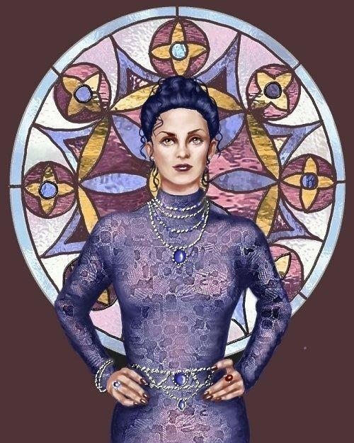
Name of Worshipped Being: Jaloux, Minor-Goddess of Jealousy & Envy

Symbol: Two eight sided stars offset on top of each other

Family relations: Second favored daughter of Mauvais, Jaloux spends a great deal of her time trying to win her father’s favor by aiding in his plans to spread evil in the world.

Goal and Purpose of Faith: To increase the enmity between nations, peoples, races and cultures actively supporting those persons who cause the most jealousy and envy in others, whenever possible.

Requirements of the Priest Hood: Find the most revered people in any society and work to turn the adoration of the public into jealousy and envy of the revered person’s goodly deeds.

Alignment Choices: Any Evil

Minimum Ability Scores: Wisdom 12, Charisma 18

Races Allowed: Any

Gender: Any

Non-weapon & Weapon Proficiencies required:
Non-weapon & Weapon Proficiencies recommended:

Duties:

Priest Hood Weapon Restrictions:

Special Requests/Limitations:

Spheres of Influences:
Major – All, Charm, Creation, Divination, Protection
Minor – Animal, Guardian, Healing, Necromantic

Granted Powers:

Followers:

Relations: Other Faiths, Aristocracy, People:

Requirements of the Followers:
Alignment Choice(s):
Races Allowed: Any.
Restrictions:

