

Name of Worshipped Being: Pryden, God of Strength – True Neutral

Symbol: Male figure holding up a mountain

Ancient Runes: Iron Fist

Family relations: Former consort of War and father of her four children. Pryuden does not favor any of his grandchildren by Kariya, Goddess of Disease and his son Frayeur, God of Terror, because he despises her and anything to do with her as weakness. He highly favors his grandchildren by Willet, God of the Hunt, who he respects and his on child he does not find weak, Cavalerie, the minor Goddess of Cavalry.

Goal and Purpose of Faith: Celebration of physical strength and nothing but strength.

Requirements of the Priest Hood: Promote physical fitness, contests of strength (such as weight-throws and wrestling) in association with priests of the Goddess of Competition (his granddaughter) and war.

Alignment Choices: Any

Minimum Ability Scores: Wisdom 12, Strength 17, and Constitution 17

Races Allowed: All races. Giants are favored.

Gender: All genders. Men are favored.

Non-weapon & Weapon Proficiencies Bonuses: Crushing blow, and Vital Area

Non-weapon & Weapon Proficiencies required: Religion, Read/Writing

Non-weapon & Weapon Proficiencies recommended: Endurance

Duties: Guidance, Marriage. The priest is not required to, but is almost always allowed to go on adventures where he will be able to display his personal strength and demonstrate the attributes of his god.

Priest Hood Weapon Restrictions: Battle-axe, cestus, club, mace, maul, morning star, picks (all), polearm, sword/two-handed, warhammer. All armor and shields.

Special Requests/Limitations: Cannot use ranged weapons. If a cleric would like to multi-class as a monk, they can, and will gain the additional bonuses of Evasion, Quickness, Improved Quickness. Only Lawful Clerics can become monks. Pryden grants +2 Strength to all monk clerics, and +4 strength to Giant monk clerics.

Spheres of Influences:
Major – All, Combat, Healing
Minor – Elemental, Necromantic
Granted Powers: Immunity to disease; Immunity to undead life-draining and paralysis, and to the spells chill touch, energy drain, enervation, ray of enfeeblement, and vampiric touch. Turn Undead. At 5th level – Incite Berserker Rage. At 8th level – Inspire Fear.

Followers: First followers are received at 8th lever and they consist of: one 5th level priest, three 3rd level priests and six 1st level priests of the same order, plus one 5th level fighter, two 3rd level fighters, and four 1st level fighters, all with Strength score of 16. At 20th level gain 20d20 – 50% Firbolg; 5% Fog Giants; 5% Cloud Giants; 10% Mountain Giants; 10% Jungle Giants; 10% Stone Giants; 10% Dessert Giants.

Relations: Other Faiths, Aristocracy, People: The God Pryden does not like the gods of Disease, and Death or their children (minor-gods) or their Chosen. The priests tend to follow their God’s otherworldly alignments with various gods. Pryden and his clergy are on good terms with the gods of Lightening, Thunder, and War; minor-goddess of Competition, and Guardianship.

Requirements of the Followers: Strength 17, Constitution 16, Wisdom 11
Alignment Choice(s): Any alignment
Races Allowed: Any. Giants are the favored race.
Restrictions: None.

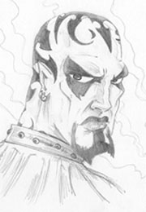
Storm Giant Avatar Form Information:

Appearance & ‘Natural’ Abilities: Ability scores: 25 all except Strength which is unknown and has yet to find its limit. Natural Armor Class: -25. THAC0: -21. Evasion 99%. Hit Points: 510. Regeneration 1d10+7 per round.

Armor: None – Pryden’s physical prowess allows him to be unconcerned about armor. He scoffs at the other gods who wear it.

Weapon’s Powers in the Hands of Pryden: Pryden’s weapons are his own two hands which he wields with supreme martial arts skills.

One Minor- Goddesses spawned by the Goddess of War, sired by Pryden, Minor-God of Strength:



Name of Worshipped Being: Cavalerie, Minor-Goddess of Cavalry – Neutral Good (ignored and despised by Brundin)
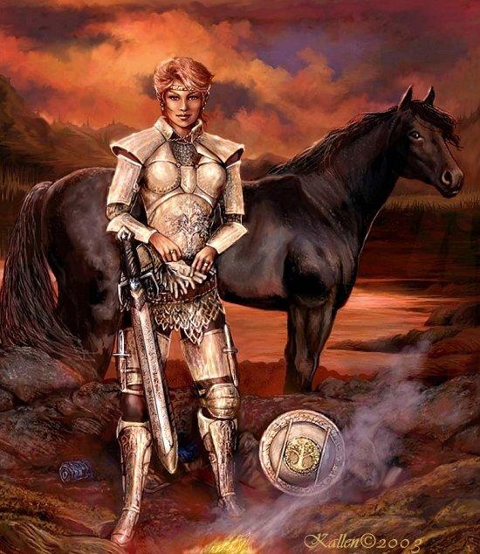

Symbol: An oak tree providing shade for a herd of horses.

Goal and Purpose of Faith: To promote the use of cavalry in armies & the good treatment of horses. Fair and wise battle tactics so as not to endanger natural wildlife or war horses. Settling of arguments and disagreement through compromise, wise decision making or competition. Patronesses of treaties and jousting.

Requirements of the Priest Hood: Applied knowledge of horse breeding and training for battle. Must be willing to die to defend horses from abuse. At 5th level, dual-class as a Cavalier must be pursued for all those Clerics of a Lawful alignment.

Alignment Choices: Any alignment consisting of Good elements

Minimum Ability Scores: Strength 17, Dexterity 16 – additionally for dual class Cavaliers Charisma 16

Races Allowed: All races.

Gender: All genders.

Bonus Non-weapon & Weapon Proficiencies: Riding-Land Based; Charioteering, Animal training; Shield.

Non-weapon & Weapon Proficiencies required: Blacksmithing

Non-weapon & Weapon Proficiencies recommended: Heraldry, Healing, Reading/Writing, Religion, Armorer, Bowyer/Fletcher, Hunting, Tracking, Leatherworking, Weaponsmithing.

Duties: Help breed, brake, and train horses for battle; Doctor ailing horses and their riders; Study, acquire, maintain and document horse breeds, and bloodlines. Aid goodly adventures and armies with mounts. Train all those who seek to learn about horses – their care and uses. Holding jousting competitions on high holidays.

Priest Hood Weapon Restrictions: Battle axe, mace, lance, maul, polearm, spear, swords (all), warhammer. All armor and shields appropriate to horse riding. Bonus: For dual-class Cavalier’s all damage done with a lance is x 4. At 15th level, Cleric/Cavaliers will receive a holy avenger.

Spheres of Influences:
Major – All, Animal, Combat, Healing, Summoning
Minor – Guardianship, Protection

Granted Powers: Polymorph animals into horses 1x per day. Talk with horses. Track horses without error.

Followers: First followers are received at 8th level and they consist of: one dozen 5th level Centaur archers. At 16th level, one dozen 10th level clerics of the same order. At 20th level gain followers of 20d20. 75% of the followers will be Cavaliers of 15th level; 10% will be 10th level Fighters; 5% will be 12th level Battle Mages; 10% will be Ferriers, Wheelrights, Squires, and Field Medics.

Relations: Other Faiths, Aristocracy, People: The Goddess Cavalerie is very much in love with her husband Willet, God of the Hunt, producing two twin daughters from their union. The Goddess Cavalerie does not like the gods of Disease, and Evil or their children (Minor-Gods) or their Chosen. Cavalerie does not care for the worshippers of Massey who abuse horses in their pursuit of plowing the fields and taming the wilds. This often causes disputes between them and other Gods and Goddesses aligned with Massey. The priests tend to follow their Goddess’ otherworldly alignments with various gods. Cavalerie and her clergy are on good terms with the Gods of Blacksmithing, Creation, Strength (her father), and Nature and their good aligned children. Cavalerie has been disowned by her mother, Brundin, the Goddess of War and is looked down upon by her brothers for wasting her talents. Worshippers of the Minor-Goddess of Cavalry are usually at odds with Brundin and her twin sons and their worshippers. They have a loose association with worshippers of the Minor-Goddess of Confusion. Cavalry and Confusion have been known to work together on the battlefield.

Each nation/city may have priests of this Goddess, and in each, the priests constitute a separate cult; even so they will always cooperate with one another even in times of war, to ensure horses are never endangered during the battle.

Requirements of the Followers:
Alignment Choice(s): Any Good alignment.
Races Allowed: Any.
Restrictions: Must never abuse a horse.

Armor: Armor of Command The finely crafted armor radiates a powerful aura of magic. When worn, the armor bestows a dignified and commanding aura upon its owner. The wearer is treated as if he or she had a Charisma of 25 for all encounter reactions. Friendly troops within 360 feet of the user have their morale increased by +2. Since the effect arises in great part from the distinctiveness of the armor, the wearer cannot hide or be concealed in any way and still have the effect function.

Weapon Powers in the hands of Cavalerie: Holy Avenger of Cavalerie is a long sword +5, holy avenger, provides 50% magic resistance in a 5-foot radius, dispel magic at 17th level in a 5-foot radius, +10 damage vs. chaotic evil opponents. If a tanar’ri is slain with the Holy Avenger of Cavalerie, the sword gains following special powers: heal once a day, strength once per day when fighting evil opponents, charm person on contact once per day. The sword will disintegrate a tanar’ri on a natural (unmodified) 20.

Weapon Powers in the hands of a mortal: All the powers are in effect. Additionally, it is telepathic with its owner, and can commune with the Minor-Goddess Cavalerie once a week. The sword’s Ego and Intelligence are 17. The sword will howl in anguish if the wielder runs from a tanar’ri. On the second instance of cowardice in the face of a tanar’ri, the sword will instantly teleport away, leaving its owner behind and return to Cavalerie.

Children of Cavalerie and Willet, God of Hunt:
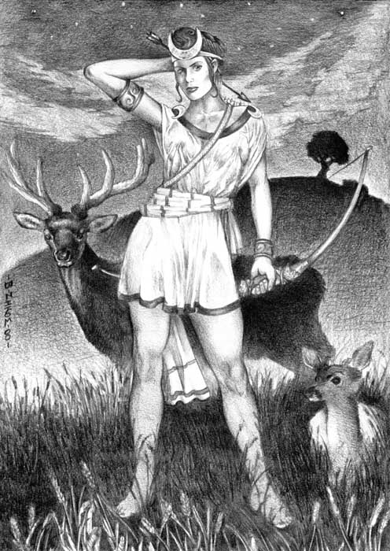
Name of Worshipped Being: Èpreuve, Minor-Goddess of Competition – True Neutral (ignored and despised by Brundin)

Symbol: A stag leaping through an upturned crescent.

Goal and Purpose of Faith: To promote fair competition and the basic belief that those who are the fittest should survive.

Requirements of the Priest Hood: Must be impartial judges at competitions that either they sponsor or are asked to adjudicate at. At 5th level must pursue dual-class as a Ranger if alignment consists of a Good element.

Alignment Choices: Any alignment consisting of Neutral or Good elements, but not Evil.

Minimum Ability Scores: Strength 17, Dexterity 16 - dual class Rangers Wisdom 16

Races Allowed: All races.

Gender: All genders.

Bonus Non-weapon & Weapon Proficiencies: Riding-Land Based; Observation; Concentration; Mastery of long bow.

Non-weapon & Weapon Proficiencies required: Bowyer/Fletcher

Non-weapon & Weapon Proficiencies recommended: Heraldry, Healing, Reading/Writing, Religion, Armorer, Hunting, Tracking, Leatherworking, Weaponsmithing, Animal Handling, Animal Lore, Animal Training.

Duties: Help train those interested in archery, jousting, or swordplay for the purposes of tournament, as well as those persons who serve as squires and judges for such tournaments. Conduct monthly tournaments and semi-annual grand competitions on high holidays that correspond with the solstices. Ensure that any competitions are fair and that nature is not compromised by the challenges. Punish those who cheat during competitions.

Priest Hood Weapon Restrictions: Long bow, Battle axe, mace, lance, maul, polearm, spear, swords (all), warhammer. All armor and shields appropriate to horse riding. Bonus: For dual-class Rangers all class abilities are increased by 5% at each increase in level.

Spheres of Influences:
Major – All, Animal, Combat, Healing, Divination
Minor – Guardianship, Plant, Weather

Granted Powers: Polymorph self into animals. Truthear; Know alignment; Bullseye shot at 10th level on a 1d20 roll of 5 or higher.

Followers: First followers are received at 8th level and they consist of: one dozen 5th level Centaur archers. At 16th level, one dozen 10th level clerics of the same order. At 20th level gain followers of 20d20. 75% of the followers will be Rangers of 15th level; 10% will be 10th level Scouts; 5% will be 12th level Battle Mages; 10% will be Ferriers, Wheelrights, Squires, and Field Medics.

Relations: Other Faiths, Aristocracy, People: The Goddess Èpreuve is very much devoted to her family – mother, father, and twin sister. The Goddess Èpreuve does not like the gods of Disease, and Evil or their children (Minor-Gods) or their Chosen. The priests tend to follow their Goddess’ otherworldly alignments with various gods. Èpreuve and her clergy are on good terms with the Gods of Blacksmithing, Creation, Strength (her grandfather), and Nature and their good aligned children. Èpreuve has been disowned by her grandmother, Brundin, the Goddess of War and is looked down upon by her uncles for her perceived weaknesses. Worshippers of the Minor-Goddess of Competition are usually at odds with Brundin and her twin sons and their worshippers. They have a loose association with worshippers of the Minor-Goddess of Confusion.

Each nation/city may have priests of this Goddess, and in each, the priests constitute a separate cult; even so they will always cooperate with one another even in times of war, to ensure that the battle is fought fairly and that the winning army won due to superior strategy and merit.

Requirements of the Followers:
Alignment Choice(s): Any alignment consisting of Neutral or Good elements, but not Evil.
Races Allowed: Any.
Restrictions: Must never cheat during a competition.

Armor: Armor of Ultimate Wisdom, +5 padded leather armor, confers 25 Wisdom and Intelligent scores upon the wearer. Access to all 7th, 8th, and 9th level Divination Mage Spells.

Weapon Powers in the hands of Èpreuve: A +5 sword of sharpness that always strikes last in any round, but which will strike unerringly and do damage to any opponent that struck at the wielder earlier in the same round, regardless of whether the opponent successfully hit the wielder, up to the wielder’s available number of attacks per round. Critical hits of 15 or higher are an automatic vorpal attack.

Weapon’s Powers in the hands of a mortal: In the hands of a True Neutral character the weapon acts as a +3 sword of sharpness that always strikes last in any round, but which will strike unerringly and do damage to any opponent that struck at the wielder earlier in the same round, regardless of whether the opponent successfully hit the wielder, up to the wielder’s available number of attacks per round.
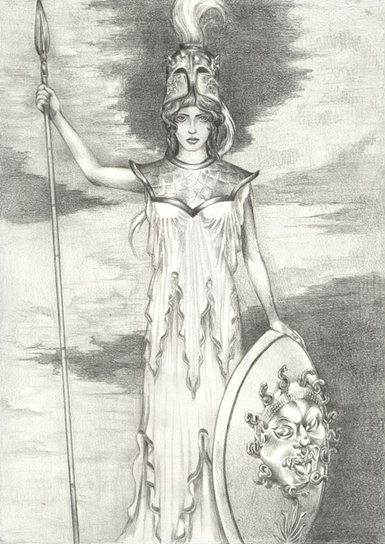
Name of Worshipped Being: Prudence, Minor-Goddess of Wisdom – Neutral Good (ignored and despised by Brundin)

Symbol: A plume quill chopping off the head of a Medusa.

Goal and Purpose of Faith: To promote the wise and judicious practice of compromise and treaties when war is not necessarily the best course of action. Promote the understanding of the unwise actions of slavery, weapons stockpiling, and deceit.

Requirements of the Priest Hood: Must aid in the negotiations of fair treaties between opposing factions for the purposes of ending aggression. Punish all those who violate the wisdom outlined in properly ratified treaties. At 5th level, all Neutral aligned Clerics must dual-class as a Bard – Lore Master.

Alignment Choices: Any alignment consisting of Neutral or Good elements, but not Evil; Favored alignments Lawful Neutral and Neutral Good.

Minimum Ability Scores: Wisdom 18, Strength 17 - dual class Bards Charisma 15

Races Allowed: All races.

Gender: All genders.

Bonus Non-weapon & Weapon Proficiencies: Persuasion; Etiquette; Oratory; Mastery of Flail & Spear; Shield

Non-weapon & Weapon Proficiencies required: For dual class Bard Lore Masters Sage Knowledge proficiencies in History, Law, Sociology and Folklore must be acquired by 20th level.

Non-weapon & Weapon Proficiencies recommended: Heraldry, Healing, Reading/Writing, Religion, Law, Scribe, Sense Motive, Singing, Poetry, Musical Instrument.

Duties: Preservation and dissemination of Wisdom and Knowledge. Offering assistance to courts, and ruling councils to add in wise solutions to arguments and quandaries.

Priest Hood Weapon Restrictions: Battle axe, flail, spear, mace, lance, maul, polearm, spear, swords (all), warhammer. Bonus: For dual-class Bards all class abilities are increased by 5% at each increase in level.

Spheres of Influences:
Major – All, Animal, Combat, Healing, Divination
Minor – Guardianship, Plant, Weather

Granted Powers: Polymorph self into animals. Truthear; Know alignment;

Followers: First followers are received at 8th level and they consist of: one dozen 5th level Centaur archers. At 16th level, one dozen 10th level clerics of the same order. At 20th level gain followers of 20d20. 75% of the followers will be Bards of 15th level; 10% will be 10th level Fighters; 5% will be 12th level Battle Mages; 10% will be Ferriers, Wheelrights, Squires, and Field Medics.

Relations: Other Faiths, Aristocracy, People: The Goddess Prudence is very much devoted to her family – mother, father, and twin sister. The Goddess Prudence does not like the gods of Disease, and Evil or their children (Minor-Gods) or their Chosen. The priests tend to follow their Goddess’ otherworldly alignments with various gods. Prudence and her clergy are on good terms with the Gods of Blacksmithing, Creation, Strength (her grandfather), and Nature and their good aligned children. Prudence has been disowned by her grandmother, Brundin, the Goddess of War and is looked down upon by her uncles for her perceived weaknesses. Worshippers of the Minor-Goddess of Wisdom are usually at odds with Brundin and her twin sons and their worshippers. They have a loose association with worshippers of the Minor-Goddess of Confusion.

Each nation/city may have priests of this Goddess, and in each, the priests constitute a separate cult; even so they will always cooperate with one another even in times of war, to ensure that the battle is fought fairly and that the winning army won due to superior strategy and merit.

Requirements of the Followers:
Alignment Choice(s): Any alignment consisting of Neutral or Good elements, but not Evil.
Races Allowed: Any.
Restrictions: Must never violate properly ratified treaties or agreements.

Armor: Helm of Wisdom and Shield of Knowledge confers 25 Wisdom and Intelligent scores upon the wearer. Access to all 7th, 8th, and 9th level Divination Mage Spells.

Weapons Powers in the hands of Prudence: Prudence’s flail and spear are highly magical weapons, flame tongue +5 whose light is blinding white. Both weapons are sentient, strictly neutral in alignment, with an Intelligence of 20 and Ego of 30. These weapons both have the following powers: read languages, read magic, know alignment, energy drain 3x per day, detect magic 1x per turn, detect invisibility, charm person 3x per day, telepathy, suggestion and slow. All powers have a -3 penalty to saving throws. All these powers are similar to spells of the same name, and operate at the 18th level.

Weapon’s Powers in the hands of a mortal: The weapons acts in the same manner in the hands of a mortal as when they are used by Prudence. The weapons communicate telepathically with the mortal wielder. They will let no one but their current owner wield them. If a wizard casts detect magic on the weapon, the caster receives a fleeting impression of the frightening power; then the connection is broken. If anyone else touches the hilt of the sword while its current owner is alive, the weapon delivers 3d12 points of electrical damage.

