

Name of Worshipped Being: Brundin, Goddess of War – Outwardly True Neutral (really Neutral Evil)
Symbol: Two crossed swords (usually red) crossed by an upright double-headed battle-axe
Heavenly Form of Brundin,
Goddess of War
Ancient Runes: Red War Horse

Goal and Purpose of Faith: The Goddess of War exists only to promote and participate in bloody battle.

Requirements of the Priest Hood: The priests want to and are required to accompany armies on the march of war. At every war, priests of this sect will be in attendance on the officers and rulers of both sides. The priests must keep their eyes open against complacency and the tide of philosophies of peacefulness. If a land is too peaceful too long, they must shake things up and get a war, even a small one, going.

Alignment Choices: Any (Although evil priests are normally publicly ostracized in good aligned settlements). Only the Chosen on the Goddess, the holder of the artifact, knows her true alignment. Although some who have had personal dealings with her know better.

Minimum Ability Scores: Wisdom 14, Strength 17

Races Allowed: All races. Dwarves are favored, and if join they priest hood are given special gifts.

Gender: All genders – males preferred.

Bonus Proficiencies for Evil Aligned Clerics: Dirty Fighting, Intimidation, Backstabbing x 3, Anatomy, and Sage Knowledge – Toxicology.

Bonus Proficiencies for all Clerics: Weaponsmithing, Close-Quarter Fighting

Non-weapon & Weapon Proficiencies required: Blind-fighting

Non-weapon & Weapon Proficiencies recommended: Animal training, Heraldry, Riding-Land Based, Healing, Reading/Writing, Religion, Armorer, Bowyer/Fletcher, Charioteering, Hunting, Running, Tracking.

Duties: Help train new warriors, teach battlefield tactics, and make records of any war or battle.

Priest Hood Weapon Restrictions: Battle axe, daggers, knifes, mace, lance, maul, polearm, spear, swords (all), warhammer. All armor and shields.

Spheres of Influences:
Major – All, Combat, Healing, Summoning
Minor – Necromantic, Protection

Granted Powers: Incite Berserker Rages; At 5th Level Inspire Fear; At 10th Level Power Word Stun. At 15th Level Brundin’s Battle Bester – when cast on combatants, gives a +5 to hit and damage, guarantee no fumble, and lowers critical threshold by 2. Can be cast only one person at a time, maximum of 5x per day. Lasts 1d4 days.

Bonus Granted Powers for Evil Aligned Clerics: Brundin’s Energy Burst – when the Cleric blesses the troops with this spell, they will immediately have morale of 19, always gain the initiative, and will be granted double the amount of their attacks. These bonuses will last 6d20 turns. The troops blessed with this will age ten years after the spell ends.

Followers: First followers are received at 8th level and they consist of: one 5th level priest, three 3rd level priests and six first level priests of the same order, plus two 5th level fighters who act as guards. At 20th level gain army of 20d20. 75% of army will be Fighters of 15th level; 10% will be 10th level Priests of War; 5% will be 12th level Mages; 10% will be either (roll 1d6 to determine): 1-Hippogriff mounts, trained and loyal to the priest; 2-Owlbear mounts, enchanted, trained and loyal to the priest; 3-Wemics; 4-Yogoloth Guardians (Least); 5-Dragonne; 6-Elephant mounts, trained for war.

Relations: Other Faiths, Aristocracy, People: The Goddess Brundin does not like the gods of Love, Peace, Dragons, or their children (Minor-Gods) or their Chosen. Brundin does not care for her daughter, Cavalerie, Minor-Goddess of Cavalry. The priests tend to follow their Goddess’ otherworldly alignments with various gods. Brundin and her clergy are on good terms with the gods of Blacksmithing, Strength, and the Hunt. Brundin is on tenuous footing with her other daughter Désordre, Minor-Goddess of Confusion, due to her current marital state to Paragon Argentus, father & chosen of the God of Dragons, Dalnoth.

Each nation/city may have priests of this god, and in each, the priests constitute a separate cult; they do not cooperate with one another in times of war, especially when their armies are opposed. In painful times of peace, these individual sects may cooperate with one another; however, they usually only do so to conspire and start up another war.

Requirements of the Followers:
Alignment Choice(s): Any
Races Allowed: Any. Dwarves favored.
Restrictions: Must use edged or bludgeoning melee weapons.

Brundin’s Dwarven Avatar Form Information –

Appearance & ‘Natural’ Abilities: Brundin appears as Dwarven female with flame red hair and black eyes. Ability scores: 25 all. Natural Armor Class: -25. THAC0: -21. Evasion 99%. Hit Points: 510. Regeneration 1d10+7 per round.

Armor: Armor of Red Flame – This armor appears to be full Dwarven plate mail. It is a weightless suit of shimmering red meteor metal. When worn in melee combat, it creates a vague shifting aura of heat giving it an other-than-solid appearance when the wearer moves. The outline of the wearer’s form becomes blurred, shifting and wavering. This distortion causes all missile and melee attacks against the wearer to be made with –4 penalties on the first attempt and –2 penalties on all successive attacks. It also grants the wearer a +1 bonus to saving throw for any direct magical attack.

The armor confers no AC protection, cannot be harmed, and does not stop physical attacks. It does not encumber or blind its wearer. Its aura conceals the features and mind of the wearer against magical and psionic scrutiny.

Another effect of the armor is that during melee a 1-foot fire aura surrounds the wearer’s body, providing complete immunity to all forms of fire, both natural and magical. A creature touched by the aura suffers 2d4 points of damage; also a victim who fails to make a saving throw vs. death magic is set afire with bright red flames. The flames persist for 2d4 rounds. Each round the victim’s attack rolls are made with a –2 penalty during this time.

Armor of Red Flame can be worn as long as desired and breathing is unrestricted. It cannot be removed unless the wearer does not resist, and can only be destroyed by a wish spell.

Armor of Red Flame protects its wearer at all times from all natural and magical heat, flame, cold, and explosive attacks. A blast might hurl a wearer of armor of red flame end over end, but no damage would be suffered. The armor’s weightlessness and total lack of encumbrance allows the wearer to swim, climb, and perform delicate tasks normally.

Weapon Powers in the hands of Brundin: Red Battle Axe of Brundin is a double-headed Vorpal battle-axe of quickness, +13 to hit, +13 to damage, goes Vorpal at 7 or higher, doubles number of attacks, improves initiative by 2. (THAC0 = -34) It also functions as a hammer +3 Dwarven thrower. Anyone hit by Brundin’s red axe must save vs. paralyzation or burst into flames. Those failing the save suffer an additional 2d10 each round and cannot cast spells, fight, or do anything but roll on the ground until the flames are put out. The flames can only be quenched through magical means; ordinary water, even holy water, has no effect on them.

Weapon’s Powers in the hands of a mortal: Acts as a huge Vorpal axe +5 that functions like a Vorpal sword. Brundin must give the axe to the mortal willingly. If someone not willingly given the axe attempts to wield it the axe releases a roaring spiral of red flame around the victim for one round inflicting 1d12 + 30 points of damage, causing all clothing, carried items, and other exposed flammable materials near to the victim to burst into flames. (Item saving throws vs. magical fire required). The axe then teleports back to the presence of Brundin no matter which plane she is on. If the wielder does not let go of the axe they will be teleported right along with it.

Other Abilities of the Red Battle Axe of Brundin: It confers on its mortal user the natural abilities of Dwarves – infravision, the ability to detect sloping passages, traps, and construction. After prolonged use, it tends to make its non-Dwarven mortal user resemble a dwarf; the user becomes shorter, stockier, and grows a profuse beard. Non-dwarf characters permanently lose 1 point of Charisma when first they touch the axe. There is a 20% chance that artifact transformation changes the user into a Dwarf instantly, losing all abilities not allowed that race. There is a 10% chance that any magical item possessed or touched by the owner is permanently negated. It also has the following abilities and penalties:
- Teleport twice per day
- Summon one 16 HD fire or earth elemental once per week
- Mortal user sustains double damage when attacked while using this relic (This is a penalty Brundin sees as a test of the user’s fighting ability and worthiness to wield the weapon.)
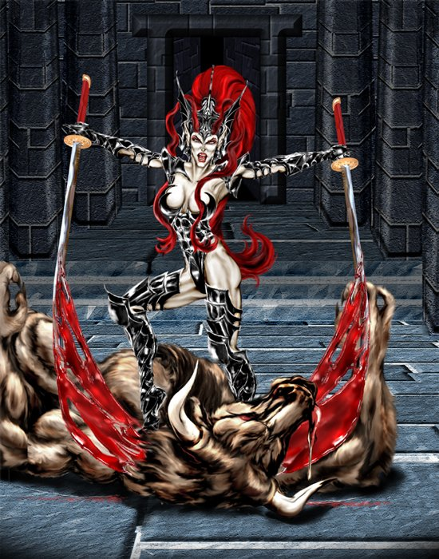
Human Avatar Form Information:

Appearance & ‘Natural’ Abilities: Brundin appears as Human female with flame red hair and black eyes (see picture at left). Ability scores: 25 all. Natural Armor Class: -25. THAC0: -21. Evasion 99%. Hit Points: 510. Regeneration 1d10+7 per round.

Armor: Armor of Black Rage – This armor appears to cover Brundin’s mid-section, legs and arms, leaving highly suggestive areas of her stunningly beautiful and muscular body quite visible. In actuality, it covers her completely, providing full protection as full Dwarven plate mail +5. It provides protection from normal as well as magical missiles.

The armor radiates a powerful aura of magic. When worn, the armor bestows a dignified and commanding aura upon its wearer. Those with Charisma scores lower than 18 have their scores increased to 18. Those with Charisma of 18 or higher gain one point to their ability scores while wearing the armor; max score 25. Friendly troops within 360 feet of the wearer have their morale increased by 2. Since the effect arises in great part from the distinctiveness of the armor, the wearer cannot hide or be concealed in any way and still have the effect function. All opponents/enemy troops within 360 feet have their morale lowered by 2.

This armor can incite Berserker Rage (once per day) on all friendly troops within 360 feet of the wearer when the command word is uttered.

In melee, the armor creates a black aura around the wearer, which acts as a globe of fumbling 15’ radius. All creatures within the 15’ radius (except the wearer) suddenly become clumsy and awkward. Running creatures trip and fall, those reaching for an item drop it; those employing weapons likewise awkwardly drop them, etc. Recovery from a fall or picking up a fumbled object typically requires a successful saving throw and takes one round. A subject succeeding with his saving throw can act freely that round, but if he is in the area of effect at the beginning of the next round another saving throw is required.

Other Abilities of the Armor of Black Rage:
- Charm person 1x per day per 3 levels of wearer
- Mass Suggestion 1x per day per 4 levels of wearer

Weapon Powers in the hands of Brundin: Twin Katanas of Black Vengence are red leather black-flecked hilted meteoric iron +5 blades of quickness, +12 to hit, +12 to damage, goes Vorpal at 8 or higher, doubles number of attacks, improves initiative by 2; (THAC0 = -33) It provides +6 to AC. The pommel of each Katana is engraved with a face that emits dull, haunting moans in battle. All opponents hearing the moans must save vs. spell or flee in fear for 1d4+1 turns.

Weapon’s Powers in the hands of a mortal: Act as Katanas of quickness – do not Vorpalize – and a Katanas of everstriking. These blades wielded by a mortal will always hit an intended target unless an impossible blow is attempted, like striking a character who is out of range. This weapon has no attack or damage bonuses, but a peculiar thing happens when such a sword is used in combat. If the sword is swung at an opponent and the die roll indicates a miss, then the wielder of the sword loses a number of hit points equal to the difference between the failed attack roll and the number needed to hit the target. Yet, the sword does hit, in effect using the wielder’s own energy to guide the attack home. This energy drain is felt as a sudden, sharp pain coupled with a feeling of exhaustion.

If the sword is used against a creature that can only be hit by magical weapons, it drains an extra set of hit points for every “plus” normally required to hit such a monster – double the amount against a creature hit only by +1 weapons, three times the amount against a creature hit only by +2 weapons, and so forth. Regardless of the number of hit points needed to make a successful attack, these katanas always do only normal damage, with a damage bonus for Strength added if applicable.

Brundin must give the blades to the mortal willingly. If someone not willingly given the blades attempts to wield them they release a roaring spiral of black diamond shards around the victim for one round inflicting 1d12 + 30 points of damage. The katanas then teleport back to the presence of Brundin no matter which plane she is on. If the wielder does not let go of the katanas they will be teleported right along with it.

Four Minor-Gods/Goddesses spawned by the Goddess of War, sired by Pryden, the God of Strength – three belong to this Pantheon:



Name of Worshipped Being: Désordre, Minor-Goddess of Confusion- Chaotic Neutral (completely insane)
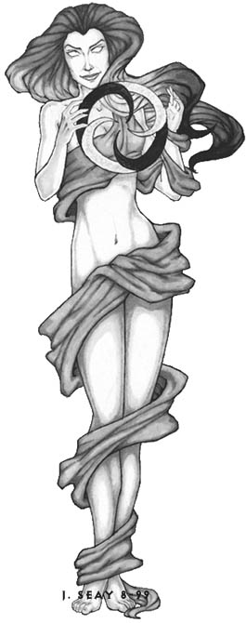

Symbol: Black and White Twisted Circle of Chaos – see picture at left

Goal and Purpose of Faith: To spread chaos in the world and destroy the foundations of a cohesive, lawful, and ordered society. Belief that intelligent beings do not need to be told how to live, or what to do.

Requirements of the Priest Hood: To promote anarchy, disobey laws, and encourage others to do so. Must pursue a dual-class by 5th level, preferably a rouge class or sub-class thereof, and if pursued, will be granted dual-class without penalties after the second class reaches 5th level.

Alignment Choices: Any alignment consisting of Chaotic elements

Minimum Ability Scores: Strength 17, Dexterity 16

Races Allowed: All races. Dwarves and humans favored.

Gender: All genders. Females of any race are favored over the males.

Bonus Non-weapon & Weapon Proficiencies: Camouflage, Disguise; specialization sword.

Non-weapon & Weapon Proficiencies required: Ambush

Non-weapon & Weapon Proficiencies recommended: Animal training, Heraldry, Riding-Land Based, Healing, Reading/Writing, Religion, Armorer, Bowyer/Fletcher, Charioteering, Hunting, Running, Tracking.

Duties: Help spread chaos by causing internal problems with the lawful and orderly running of government. This could entail robbing tax-collectors and redistributing wealth, toppling lawful governments and instituting anarchy, or assassinating judges or members of ruling bodies or courts.

Priest Hood Weapon Restrictions: Battle axe, daggers, knifes, mace, lance, maul, polearm, spear, swords (all), warhammer. All armor and shields. Bonus: If second chosen class is Thief or Assassin, there will be no armor penalties on class abilities only for duties performed in service to the Goddess.

Spheres of Influences:
Major – All, Chaos, Combat, Healing, Summoning
Minor – Necromantic, Protection

Granted Powers: Produce chaos 30’ foot radius – all initiative rolls, saving throws, evasion rolls, and magic resistance (chosen by rolling 1d4) rolls will be affected by the DM’s roll and Cleric’s roll of percentile dice excluding the Cleric. The lowest rolling person will then roll 1d6 and this will determine the effect of the chaos produce – even numbers lower the saving rolls by the amount rolled and odd numbers raise the saving rolls by the amount rolled. At 10th level the radius increases to 60’ and the determining die is now 1d10. At 18th level the radius increases to 120’ and the determining die is now 1d12 x 1d4. At 26th level, the radius is increased to 240’ and the determining die is now 1d20 x 1d4.

Followers: First followers are received at 8th level and they consist of: one dozen 5th level Leprechauns. At 16th level, one dozen 10th level clerics of the same order. At 20th level gain followers of 20d20. 75% of the followers will be Thieves of 15th level; 10% will be 10th level Assassins; 5% will be 12th level Mages; 10% will be either (roll 1d6 to determine): 1-Charlatans; 2-Pirates/Smugglers; 3- Counterfeiters; 4-Acrobats/Tumblers; 5-Joungleurs; 6-Blade.

Relations: Other Faiths, Aristocracy, People: The Goddess Désordre is very much in love with her husband Paragon Argentus, so completely so, that when she is in his presence, he actually effects her personality and mental state. When in his presence, she does not enforce her own ethos, and yields to his own will – which is Lawful Good. Most find this situation rather confusing, which Désordre appreciates fully. It also pleases her that Paragon was once a Paladin of Brundin and hates his mother-in-law to no end. Désordre is content to make her home in Wyrmhelm among mortal sentients and is a doting mother.

Worshippers of the Minor-Goddess of Confusion are not normally at odds with Brundin and her twin sons and their worshippers. They have a loose association with worshippers of the Minor-Goddess of Cavalry. Cavalry and Confusion have been known to work together on the battlefield, in such cases, Brundin and her sons treat Désordre with contempt. Each nation/city may have priests of this Goddess, and in each, the priests constitute a separate cult; they do not cooperate with one another, at all.

Requirements of the Followers:
Alignment Choice(s): Any Chaotic alignment.
Races Allowed: Any. Dwarves and humans favored.
Restrictions: Shouldn’t follow the laws of mortals.

Armor: Armor of Confusion is Mithril chain mail +5. The armor shifts colors and charms/stuns onlookers, acting like a Robe of Scintillating Colors. Negates bonus on saving throws vs. spell derived from magic items. Any Mage within 50’ of the wearer of this armor must roll on the Wild Mage spell casting chart. All sentients in combat with the wearer defend as if constantly surprised.

Weapon Powers in the hands of Désordre: Blade of Chaos – this +5 weapon of quickness takes the shape of any bladed/edged weapon the wielder desires – instantly. During melee it can change in mid-strike so that all parry attempts fail automatically – basically negating the ability to parry. Damage changes accordingly based on the shape the blade is when it actually hits the target. Due to its immense chaos emanations, any non-Chaotic aligned sentient within a 40’ radius must make a saving throw vs. petrifaction each round they are engaged in combat and within the radius or be stunned 1d4 rounds and loose 1 point of Constitution permanently. This can happen multiple times. After a failed saving throw, the stunned sentient makes the next saving throws at a -2. The ability points can only be returned by Divine Intervention or a wish. Any sentient that fails a saving throw by more than half will have their alignment shift one step toward Chaotic, thus a Lawful character failing a throw by more than half will become Neutral, and a Neutral character Chaotic.

Weapon’s Powers in the hands of a mortal: Act as Blade of quickness +3. The shape-shifting ability can only be used once per round and not in the middle of a strike. Only if the opponent is surprised, does the negating of the parry apply. Once an opponent has seen the blade change, the negating ability will not work for a mortal, unless they are also wearing the Armor of Confusion. Chaos emanations still apply without the loss of Constitution or alignment change.

Désordre must give the blade(s) to the mortal or demi-mortal willingly. If someone not willingly given the blade(s) attempts to wield them they release a roaring spiral of black & white chaos circles around the victim for one round inflicting 1d10 + 20 points of damage. The blade(s) then teleport back to the presence of Désordre no matter which plane she is on. If the wielder does not let go of the blade(s) they will be teleported right along with it.

Children of Désordre and Paragon Argentus – Father & Chosen of Dalnoth:

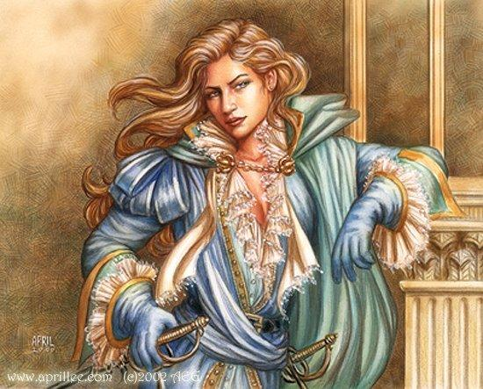
Esmarelda Argentus (non-ascended; half-sister to Dalnoth)
Alias “Black Ivy” – True Neutral
Race: Human (Demi-Goddess)
Class: Bard - Jongleur
Deity: Hassard
Status: Mother’s Favorite – despite the fact she worships Hassard
Weapon of Choice: Mithril Rapier of Chaos (gift from her mother)
Birth Rank: Last born of quadruplets
Whereabouts: Unknown

Son Argentus–Demi-God;Dwarven (non-ascended; half-brother to Dalnoth)
Son Argentus–Demi-God;Dwarven (non-ascended; half-brother to Dalnoth)
Son Argentus–Demi-God;Dwarven (non-ascended; half-brother to Dalnoth)


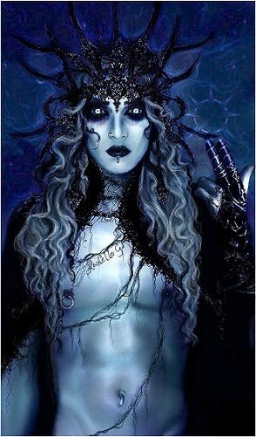
Name of Worshipped Being: Frayeur, Minor-God of Terror – Chaotic Evil

Symbol: Eight pointed hollow sun of darkness.

Goal and Purpose of Faith: To keep people afraid of disobeying the wishes of the gods – especially those to whom Frayeur is aligned with – basically the evil gods and goddess. To promote fear and distrust which could lead a community to war.

Requirements of the Priest Hood: Perform rituals designed to inspire terror in the hearts of all beings. Blood sacrifice of virgins, the innocent, children, etc from the families of those not properly respectful of the gods. To teach warriors how to inspire terror in their foes on the battlefield.

Alignment Choices: Any Neutral or Chaotic alignment not containing the element Good.

Minimum Ability Scores: Wisdom 15, Strength 17

Races Allowed: All races.

Gender: All genders.

Bonus Non-weapon & Weapon Proficiencies:

Non-weapon & Weapon Proficiencies required:

Non-weapon & Weapon Proficiencies recommended: Reading/Writing, Religion,

Duties: To frighten and terrorize the local populace into devotion to the Evil deities, particularly those of the Pantheon of War.

Priest Hood Weapon Restrictions: Battle axe, mace, lance, maul, polearm, spear, swords (all), warhammer.

Spheres of Influences:
Major – All, Combat, Divination, Summoning
Minor – Necromantic, Chaos

Granted Powers: Inspire Fear; Slow 50’ radius against opponents.

Followers: First followers are received at 8th level and they consist of: one dozen 5th level Ogres. At 16th level, one dozen 10th level clerics of the same order. At 20th level gain followers of 20d20. 75% of the followers will be Trolls of 15th level; 10% will be 10th level Fighters; 5% will be 12th level Battle Mages; 10% will be either (roll 1d6 to determine): 1-Hippogriff mounts, trained and loyal to the priest; 2-Owlbear mounts, enchanted, trained and loyal to the priest; 3-Wemics; 4-Yogoloth Guardians (Least); 5-Dragonne; 6-Elephant mounts, trained for war.

Relations: Other Faiths, Aristocracy, People: The God Frayeur does not like the gods of Love, Peace, Dragons, or their children (Minor-Gods) or their Chosen. Frayeur does not care for his sister, Cavalerie, Minor-Goddess of Cavalry. The priests tend to follow their God’s otherworldly alignments with various gods. Frayeur and his clergy are on good terms with the gods of Disease, Strength, and Evil. Frayeur is on tenuous footing with his brother, Divaguer, Minor-God of Rage due to his outcast status from heaven, and his sister Désordre, Minor-Goddess of Confusion, due to her current marital state to Paragon Argentus, father & chosen of the God of Dragons, Dalnoth, who happen to kill his twin brother.

Each nation/city may have priests of this god, and in each, the priests constitute a separate cult; they do not cooperate with one another in times of war, especially when their armies are opposed. In painful times of peace and happiness, these individual sects may cooperate with one another; however, they usually only do so to conspire and start up another war and spread terror.

Requirements of the Followers:
Alignment Choice(s): Any Neutral or Chaotic alignment not containing the element Good.
Races Allowed: Any.
Restrictions: Must frighten and terrorize sentients when the opportunity arises.

Armor: Helm of Terror and Robe of Fright all enemies within 80’ of the combination of the helm and robe must make an immediate morale check. All subsequent morale checks in the zone of influence suffer a -4 penalty per 20 feet of distance they continue to close on the wearer of the combo to a maximum of -12. Those touching the wearer with anything other than a weapon are struck instantly with uncontrollable dread, freezing in place, loosing their bowels, and whimpering like a scared child. There is no saving throw against this fear effect. Only Clerics of the deity know about the powers of this terrible combo and if they speak of it to anyone outside the priesthood their tongue and eyes fall out, and continue to ooze blood until the person dies, ensuring an extremely painful, slow, and terrorizing punishment to behold.

Weapon Powers in the hands of Frayeur: The Entity is a huge tri-bladed great sword. The central blade is the equivalent of a long sword of sharpness while the two outer blades are similar in size to short swords of sharpness. On a hit, the damage is 2d12+1d8 damage, with a +5 bonus for the weapons enchantment. The two outer blades can be shot from the hilt, attacking as arrows of accuracy +4. If the arrows miss their target, the blades fly back to the sword like a pair of boomerangs and reattach by the end of the current round. Across the hilt, the sword has 12 small black knives (about the size of well-balanced pocket knives). These knives of venom +1 can be thrown causing 1d4+1 base damage, and type C Poison damage. The equivalent of an unholy reaver (with all powers), its primary purpose is the destruction of law and good – and the bringing of fear and terror. It can detect invisible objects and creatures, can communicate telepathically with its user, and has a chaotic evil alignment. It has an Intelligence of 21 and an Ego of 20.

Weapon’s Powers in the hands of a mortal: Frayeur never willing gives his weapon to any mortal other than his Chosen. When he does lend his weapon to his Chosen, it acts exactly as if Frayer is using it with the exception that it will attempt to control the wielder. Being that this would be a gift from the chaotic deity, the sword’s critical of 20 requires a roll on the Critical Effect Chart, listed below. The table’s has effects that damage both user and opponent. All results are cumulative where applicable.

01 | Life stealing: Treat as the sword of the same name.
02 | Damage the possessor: The blow harms the wielder instead of the opponent.
03 | Confusion: Effect lasts 2d4 rounds, save for half effect.
04 | Double damage to possessor: The sword transfers double the damage of the strike from the opponent to the wielder.
05 | Disintegrate: The opponent is disintegrated unless a saving throw vs. spell is successful
06 | Deafness: Wielder is struck deaf until a remove curse or heal is cast. No save applicable.
07 | Drain Energy Levels: 1d5 levels are drained from the opponent. A save vs. spell is applicable
08 | Teleport: Wielder is teleported to a random (hospitable) location within 1,000 miles of current location
09 | Vorpal attack: Treat as a vorpal sword
10 | Tasha’s uncontrollable hideous laughter: Wielder is struck with 2d4 rounds of the named spell. Saving throw vs. spell applies.
11 | Blindness: Opponent is permanently blinded. Save vs. spell applies.
12 | Drain Energy Levels: One level is drained from the wielder. Save vs. spell applies.
13 | Teleport: Opponent is teleported to a random (hospitable) location within 1,000 miles of current location
14 | Mute: Both wielder and opponent are dumb for 1d4 days (roll randomly for each)
15 | No Special Effect
16 | Growth: Opponent’s nose, ears, facial hair, and lips grow to six times their normal size.
17 | No Special Effect
18 | Shrinkage: Opponent’s weapon shrinks to the size useable by the smallest Sprites.
19 | No Special Effect
20 | Regeneration: Both wielder and opponent are instantly regenerated all hit points (but not levels) lost during this melee.

If one mortal other than the Chosen does pick the weapon up they are struck with insanity (Wisdom reduced to 3; Intelligence decreased by half) and 10 randomly chosen phobias. Only Divine Intervention or a wish can restore the mind and ability scores of the person affected.


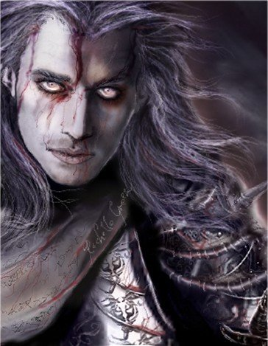
Name of Worshipped Being: Divaguer, Minor-God of Rage – Chaotic Evil (killed by Paragon Argentus and Alex Didndoit) – Reborn as a Vampire – currently living as a half-ascended demi-god, whereabouts unknown.

Symbol: Humanoid form sprouting bat-like wings with a crown above his head.

Goal and Purpose of Faith: To promote anger and rage to further the likelihood of war.

Requirements of the Priest Hood: To aid in the full ascension of their God to the heavens. To start fights and arguments whenever possible. To actively destroy anything of Paragon Argentus or Alex Didntdoit’s making – including their children.

Alignment Choices: Any Neutral or Chaotic alignment not containing the element Good.

Minimum Ability Scores: Strength 17, Constitution 18

Races Allowed: All races except humans.

Gender: All genders. Females must submit to sexual activities with the deity on a regular basis.

Bonus Non-weapon & Weapon Proficiencies: none

Non-weapon & Weapon Proficiencies required: none

Non-weapon & Weapon Proficiencies recommended: Reading/Writing, Religion

Duties: To aid their God in reascending to the heavens by converting sentients to his worship and gaining him additional powers from daily prayer.

Priest Hood Weapon Restrictions: No silver weapons

Spheres of Influences: currently the God has no powers to bestow upon his Clerics; these spheres are granted by the Goddess Brundin in return for Divaguer’s Clerics being ‘on call’ whenever she wants them.
Major – All, Combat, Summoning
Minor – Necromantic

Granted Powers: Will turn Clerics swearing undying faithfulness to him into Vampires. All abilities of a vampire – polymorph into bats, wolves, mist, shadow. Control lesser undead. Energy drain.

Followers: None granted – yet.

Relations: Other Faiths, Aristocracy, People: Outcast from the heavens due to his defeat by Paragon Argentus and Alex Didndoit, Divaguer lives as a Vampire half-ascended demi-god. He still has relationships with his mother and twin brother, but is now subservient to them. Additionally, he is a servant of the other Evil Gods of the Greater Pantheons – Kariya and Mauvais. Currently, Divaguer fancies himself as the self-proclaimed King of the Undead, and has made himself an enemy of the Goddess of Death a former ally.

Requirements of the Followers:
Alignment Choice(s): Any Neutral or Chaotic alignment not containing the element Good.
Races Allowed: Any.
Restrictions: Daily prayer. Monthly blood sacrifice of a human to the deity.

Armor: No armor of his own power – granted armor from his Mother.

Weapon Powers in the hands of Divaguer: No weapons of his own power – granted weapons from his Mother

