The Life and Works of

Kenji Misumi
1921-1975

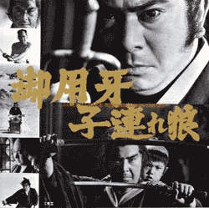

HND Moving Image Year 1
April 2002
Contextual Studies Brief 2

So, who was Kenji Misumi?
Well, he was a film director in Japan during the second half of the 20th century, notably in the 1960’s to 1970’s, making some of the worlds more famous films of the modern chambara genre. He is little known outside of Japan, only really known among fans of chambara for films such as Shogun Assassin, Zatoichi and Lone Wolf and Cub.
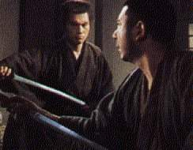
Chambara is the name of the genre of high octane and usually super violent type of samurai films, the most well known director of which is Akira Kurosawa. Obviously most of this type of film is made in Japan (except films such as The Bushido Blade, made in the USA and psuedo samurai films such as American Samurai and The Sword Of Bushido) and is not often seen beyond its shores, in spite of this its influences are far reaching in the world of film, most notably Seven Samurai directed by Akira Kurosawa which went on to be remade in America as the western The Magnificent Seven, and was one of the main inspirations of George Lucas’s film Star Wars.
Kenji Misumi was born in September 1921 as the son of a rich family in Kyoto and initially though he studied economics at a prestigious and exclusive University, he had really always wanted to make films and went daily to the local cinema to watch samurai films. It was from these early films that he received his influences in the genres of film that he would later make.
A still from one of the Zatoichi films directed by Misumi
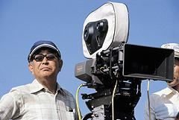
In 1941 he began his career by joining the Nikkatsu production company, producing his first feature film in 1954. He remained working with them until 1972, all the films that he produced making a lot of money in Japanese cinemas. In 1961 he therefore was selected to produce the first film in Japan to be shot on the very expensive format 70mm film, “Shaka/ Buddha”. The success of this film made Misumi famous across Japan as a top-notch producer. (1)
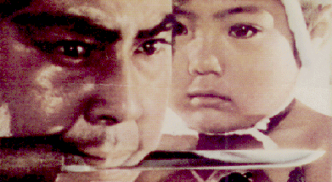
But, after this success he began directing as he had always wanted to do, working on the type of films that he had always wanted to make - his own unique style of Chambara. (2)
Akira Kurosawa
His first famous films were the Zatoichi series, about a blind
“troubleshooting” swordsman, made in the late 1960s and early 1970s (3), but he is probably most famous, certainly outside Japan, for the notorious Lone Wolf And Cub (also known as Okami, Kozure Okami, or the Baby cart Assassin) series made between 1972 and 1975, of which he directed from the manga comic series created by Kazuo Koike and Goseki Kojima. (4)
Lone Wolf And Cub

Due to the fact that American films are shown worldwide they have obviously had a large influence on film making all over the world. So that while the influences on Misumi’s film making are obviously mainly Japanese, you can also see influences of Sergio Leone’s violent “spaghetti westerns” work especially in Lone Wolf And Cub, and in its inspiration the sometimes almost poetic works of Akira Kurosawa initially inspired by the films of John Ford, (5) and Kurosawa’s use of the ronin character (ronin means masterless samurai by the way) as the main protagonist, but in the main you see the influences of Manga.
Lone Wolf And Cub
Manga are comics usually made for adults that are really the traditional Japanese version of a trashy paperback novel. Each and every shot of the films is in the style of a picture from a manga comic – to prove this all you need to do is to read some of the Lone Wolf And Cub comics and note the style of image, then look at the films, and although the film is obviously not taking the comic as a storyboard, you will see exactly the same sort of image style. The extreme (to Western eyes) violence and sex that characterizes Manga comics is carried over beautifully and artistically into Misumi’s films. Unlike the earlier films by directors such as Kurosawa, the films are not so often light hearted, easygoing action films filmed with some thought still given to the sensibilities of an audience!!!!
By the time Misumi was making films, Chambara films had evolved from the earliest samurai films made in about 1910 by film makers such as Makino Shojo, through the War years where films such as The Loyal Forty Seven Ronin were made to depict heroic tales from Japans past (to inspire people as part of the governments propaganda with images depicting loyalty and self-sacrifice), been suppressed during the American occupation after World War 2 where these films were viewed as a threat to the occupying forces, changed from the style of post war films like Seven Samurai (which, totally inaccurately, tries to depict the samurai as an almost Robin Hood like character), through to the re-emergence of the violent, often amoral action characterized by films such as Yojimbo (directed by Kurosawa) over the years again becoming became notorious for their graphic on screen depictions of literal fountains and rivers of arterial gore (often even sprayed into the camera lens!) and the obligatory graphic sex scenes usually depicting rape. In fact, although Kurosawa’s films seem tame, almost boring in comparison, he was the one of the first to begin introducing “grit” to samurai films again after the War, in the 1950s. (6)
The style of Misumi’s films is darker too, with very complicated (more complicated that we are used to in the West) and usually very grim storylines, more amoral characters even as main characters such as Itto Ogami, who is the main character of Lone Wolf And Cub.
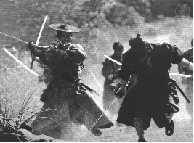
His films also tend to depict the less “pretty” side of feudal Japan, and are historically pretty accurate about the types of situations that people could and did get into in those days before the Meiji Restoration in 1867 which ended the days of Japan as a feudal state and ended the rule of the samurai. This may sound like a depressing thing to watch but when you follow a series taking careful note of the intricacies of the stories, it becomes very interesting, and the fact that every shot is beautifully composed, and every fight is carefully choreographed make the films a pleasure to watch – if you can stand the previously mentioned graphic depictions. There is also usually an underlying storyline of honour, even in those films about apparently amoral characters, which is quite refreshing after a lot of Western entertainment. (7)
The beautiful cinematography of Lone Wolf And Cub

While a lot of people in the West have seen Shogun Assassin, which is a dubbed film, comprised of parts of the first two Lone Wolf And Cub films Sword Of Vengeance and Babycart At The River Styx, the original series of six films are still fairly unknown. This is probably because of the fact that due to the violence levels the films were banned until the late 1990s in the UK, when a company called Artsmagic, which specializes in the release of samurai films on video in the UK, decided to release them on video and DVD. (8)

In the USA the films have been available for longer than in the UK but a film in a foreign language is never as popular as one in the native language due to the fact that a lot of people don’t like to watch a film that is subtitled. In addition to this, samurai films often deal with concepts far removed from daily Western life or history. (9)

It appears though that there are a lot of people who are becoming fans of chambara in this country. Often now I see Misumi’s films for sale in HMV or Virgin Megastores, and they sell fast, especially the Lone Wolf And Cub films. The Zatoichi films seem to be taking a little longer to catch on, but this is only information I have gleaned from personal observations in Plymouth’s video stores over the past year and a half.
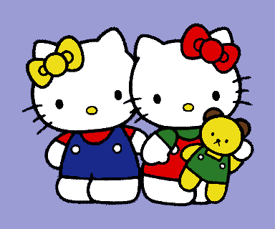
The early 1970s were the heyday of these super violent chambara epics, (just as in the West violent action films were also in their heyday) (10), in the 1980s their popularity began to decline somewhat but they appear to be making a comeback as people look for escapism from modern society again.

In Japan the culture of popular entertainment is very much different from our own here in the West. You will sometimes see pretty little Hello Kitty toys for children side by side with sex toys or pornographic magazines for adults on shop shelves in Tokyo shops (as illustrated in a recent TV documentary). This illustrates the difference of views of people wanting entertainment between in Japan where film such as Zatoichi are not seen as any worse than Indiana Jones, and in the West, where such liberalization would be deemed totally unthinkable. In Japan depictions of violence and sex are much more
Hello Kitty
acceptable in films and entertainment as a whole, hence the fact that until recently Western markets have been reluctant to show these films and the fact that Japanese film appears to have pushed the boundaries of movie acceptability to its limits means that it is only in very recent years that film censors have approved these film in many countries. (11)
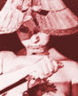
There are still universal elements that you will see in Japanese films as well as western films. In Misumi's films you see use of the “Femme Fatale” character, which derives from film noir in the West in the 1950s, most namely the character Oyuki in the third Lone Wolf and Cub who is the inspiration for a spin off series Lady Snowblood. You also will see shots that appear to look of the same style as you would see in a western which have reached out their influence to Misumi and other filmmakers of his ilk via Kurosawa’s massive influences on film making in Japan and around the world and vice versa. Misumi did attempt to take samurai films in a new direction with his film “The Razor: Sword of Justice” mixing the traditional samurai genre with porn and crime moves, but this series did not seem to catch on so much. You do not hear so much about this series and hardly ever anything complimentary.
Oyuki
Misumi’s films always contain what to us in the west is extreme violence and violent sex, but by taking it further with “The Razor” he seemed to overstep the mark.
It is very interesting to note that on the Internet you will often find Misumi’s films listed in the horror sections of video sale websites. Technically these films are not horror but through the extremity of their imagery, they are classed as such in the UK and USA. (13)
These films have had their own influence in turn, not just upon my own student filmmaking, which is fairly unimportant in the grand scheme of things, but also upon that of far more important filmmakers. In fact rival film companies did try to later resurrect both the series on Lone Wolf And Cub, and Zatoichi by making more films in both series, but lacking the original people both acting and as film crews, these films were mainly unsuccessful. It is said that Lone Wolf And Cub directly inspired Quentin Tarantino to write the samurai sword sequence in Pulp Fiction, (14) with the samurai sword as Butch’s hope of redemption and survival and that it inspired the making of Crying Freeman, billed, certainly on the posters for the UK release as the first ever live action manga film, after Lone Wolf and Cub was the proof in the early 1970s that you can make popular action films from manga. (15)
Unfortunately Misumi is now deceased, and we do not hear about the samurai films that are currently being produced, from in the West so I am not able to compare these films to more recent Chambara releases. Samurai films are still a popular form of entertainment, especially in Japan with older generations and with globalization it is becoming more popular outside Japan as well. Not until the last few years have I seen these films on video in shops like Virgin Megastores, not even the more “acceptable” ones like the films by Akira Kurosawa and the like. This comes in a wave of worldwide films appearing in the shops now. This is marvelous because films worldwide can be influenced by so many different cultures now instead of only by Hollywood and /or the films and popular culture of your own native country. This is sure to add to the diversity and interest of films around the world.

References

(1) Bare Buehrer, B, (1990) Japanese Films A Filmography and Commentary, 1921-1989, London, St James Press, pages 159-162

(2) unknown, date unknown, Okami 2 At The Dead River (online), Available from http://www.rapideyemovies.de/dvd-video/okami-2/backgrounds.php (accessed 14/02/02)
General information about Misumi’s origins

(3) unknown, date unknown, Zatoichi The Blind Skilled Swordsman (online), Available from www.filmonline.com.ar/42/notas/zatoichi/zatoichi.htm (accessed 07/02/02)

unknown, date unknown, Japonline - Fiche Cinema _ Zatoichi_Le sabreur aveugle (online), Available from http:// japonline.free.fr/Culture-cine-film-zatoichi_serie.htm (accessed 07/02/02)

(4) unknown, date unknown, Babycart To The River Styx (online), Available from http://www.splatterhouse.net/reviews/a-b/babycart.html. (accessed 07/02/02)

(5) unknown, 1999, Jims Real Detroit Collumn (online), Available from http://www.thomasvideo.com/realdetroit/realdetroit8599.html. (accessed 07/02/02)

(6) unknown, date unknown, An Introduction To Early Japanese Cinema (online), Available from http://www.Latrobe.edu.au/screeningthepast/classics/rr0499/PUerr6.htm (accessed 21/03/02)

unknown, date unknown, Tragic Poignancy Kenji Mizoguchi’s The Loyal Forty Seven Ronin (online), Available from http://www.brightlightsfilm.com/26/ronin.html (accessed 21/03/02)

unknown, date unknown, Blood Spear, Mt Fuji Uchida Tomu’s Conflicted Comeback From Manchuria (online), Available from http://www.brightlightsfilm.com/33/tomu2.html (accessed 21/03/02)

(7) unknown, date unknown , The Lone Wolf And Cub Experience (online), Available from http://icydeath.www.50megs.com/reviews/LoneWolf..htm. (accessed 07/02/02)

unknown, date unknown, Babycart To The River Styx (online), Available from http://www.splatterhouse.net/reviews/a-b/babycart.html. (accessed 07/02/02)

(8) www.artsmagic.co.uk (go to their samurai catalogue)

(9) unknown, date unknown, Babycart To The River Styx (online), Available from http://www.splatterhouse.net/reviews/a-b/babycart.html. (accessed 07/02/02)

(10) unknown, 1999, Jims Real Detroit Collumn (online), Available from http://www.thomasvideo.com/realdetroit/realdetroit8599.html. (accessed 07/02/02)

(11) www.asia-inc.com/index.php?articleD=21356

(12) unknown, date unknown, The Razor (online), Available from http://www.culturedose.com/review.php?rid=10002149 (accessed 21/03/02)

(13) www.splatterhouse.net

(14) unknown, date unknown , Pulp Fiction (online), Available from http://www.awcm.com/bbb/nr/990302.htm (accessed 07/02/02)

(15)see the video posters for Crying Freeman

