2004
OUR ANNUAL SHOW

INCORPORATING

AUSTRALIAN CHRYSANTHEMUM
CHAMPIONSHIP
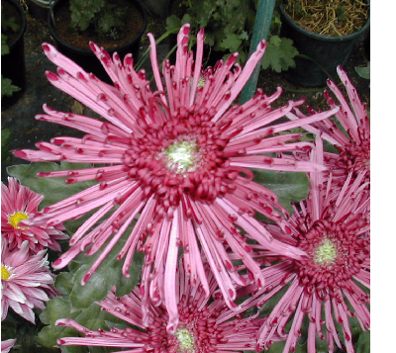

REEDBEDS

COMMUNITY CENTRE

****

FITCH ROAD
Fulham

Sat. 1st May
1pm - 5pm

Sun. 2nd May
10am—4pm

Followed by

AUCTION OF BLOOMS

